# Standard equipment of stands

|  |
| --- |
| **Special offer.**  **Equipment of the stand with an area of 3 sq.m.** |

|  |  |  |
| --- | --- | --- |
|  | **3 sq.m.** | • carpet (color to choose: gray, blue, red, green)  • wall panels (white)  • fascia board  • company name on the fascia board (no more than 20 characters, color blue)  • 1 spot-sconce  • 1 220V socket (1 kWt)  • 1 information desk 500 x 1000 x 1100 mm  • 2 bar stools  • 1 wall hanger  • 1 wastebasket |
| C:\Users\User\AppData\Local\Microsoft\Windows\INetCache\Content.Word\Безымянный.png | |

|  |
| --- |
| **Equipment of the stand area from 6 to 8 sq.m.** |

|  |  |  |
| --- | --- | --- |
|  | **6 sq.m.** | • carpet (color to choose: gray, blue, red, green)  • wall panels (white)  • fascia board  • company name on the fascia board (no more than 20 characters, color blue)  • 2 spot-sconces  • 1 220V socket (1 kWt) **(in case of payment**  **registration fee)**  • 1 information desk 500 x 1000 x 1100 mm  • 1 table 700 x 700 mm  • 2 chairs  • 1 wall hanger  • 1 wastebasket |
| 6  C:\Users\User\AppData\Local\Microsoft\Windows\INetCache\Content.Word\Безымянный2.png | |

|  |
| --- |
| **Equipment of the stand area from 9 to 11 sq. m** |

|  |  |  |
| --- | --- | --- |
|  | **9 sq.m.** | • carpet (color to choose: gray, blue, red, green)  • wall panels (white)  • fascia board  • company name on the fascia board (no more than 20 characters, color blue)  • 2 spot-sconces  • 1 220V socket (1 kWt) **(in case of payment**  **registration fee)**  • 1 information desk 500 x 1000 x 1100 mm  • 1 table 700 x 700 mm  • 3 chairs  • 1 wall hanger  • 1 wastebasket |
| 9  C:\Users\User\AppData\Local\Microsoft\Windows\INetCache\Content.Word\Безымянный3.png | |

|  |
| --- |
| **Equipment of the stand area from 12 to 17 sq. m** |

|  |  |  |
| --- | --- | --- |
|  | **12 sq.m** | • carpet (color to choose: gray, blue, red, green)  • wall panels (white)  • 1 sliding door  (a Deposit is required for the key)  • fascia board  • company name on the fascia board (no more than 20 characters, color blue)  • 3 spot-sconces  • 1 220V socket (1 kWt) **(in case of payment**  **registration fee)**  • 1 information desk 500 x 1000 x 1100 mm  • 1 table 700 x 700 mm  • 4 chairs  • 1 rack (4 shelves) 800 x 300 x 2000 mm  • 1 z-shaped prospectus holder  • 1 wall hanger  • 1 wastebasket |
| 12 | |

|  |
| --- |
| **Equipment of the stand area from 18 to 29 sq. m** |

|  |  |  |
| --- | --- | --- |
|  | **25 sq.m** | • carpet (color to choose: gray, blue, red, green)  • wall panels (white)  • 1 sliding door  (a Deposit is required for the key)  • fascia board  • company name on the fascia board (no more than 20 characters, color blue)  • 4 spot-sconces  • 1 220V socket (1 kWt) **(in case of payment**  **registration fee)**  • 1 information desk 500 x 1000 x 1100 mm  • 1 table 700 x 1400 mm  • 4 chairs  • 1 rack (4 shelves) 800 x 300 x 2000 mm  • 1 z-shaped prospectus holder  • 1 wall hanger  • 1 wastebasket |
| 25 | |

|  |
| --- |
| **Equipment of the stand area from 30 to 42 sq. m** |

|  |  |  |
| --- | --- | --- |
|  | **30 sq.m.** | • carpet (color to choose: gray, blue, red, green)  • wall panels (white)  • 1 sliding door  (a Deposit is required for the key)  • fascia board  • company name on the fascia board (no more than 20 characters, color blue)  • 6 spot-sconces  • 1 220V socket (1 kWt) **(in case of payment**  **registration fee)**  • 2 information desk 500 x 1000 x 1100 mm  • 1 table 700 x 1400 mm  • 1 table 700 x 700 mm  • 6 chairs  • 1 locker 500 x 1000 x 700 mm (without lock)  • 1 rack (4 shelves) 800 x 300 x 2000 mm  • 1 z-shaped prospectus holder  • 1 wall hanger  • 1 wastebasket |
| 30 | |

|  |
| --- |
| **Equipment of the stand area from 43 to 54 sq. m** |

|  |  |  |
| --- | --- | --- |
|  | **48 sq.m.** | • carpet (color to choose: gray, blue, red, green)  • wall panels (white)  • 2 sliding doors  (a Deposit is required for the key)  • fascia board  • company name on the fascia board (no more than 20 characters, color blue)  • 8 spot-sconces  • 1 fluorescent lamp  • 1 220V socket (1 kWt) **(in case of payment**  **registration fee)**  • 4 information desks 500 x 1000 x 1100 mm  • 1 table 700 x 1400 mm  • 1 table 700 x 700 mm  • 8 chairs  • 1locker 500 x 1000 x 700 mm (without lock)  • 2 racks (4 shelves) 800 x 300 x 2000 mm  • 2 z-shaped prospectus holders  • 1 wall hanger  • 1 wastebasket |
| 48 | |

**Equipment of the stands - Standard +**

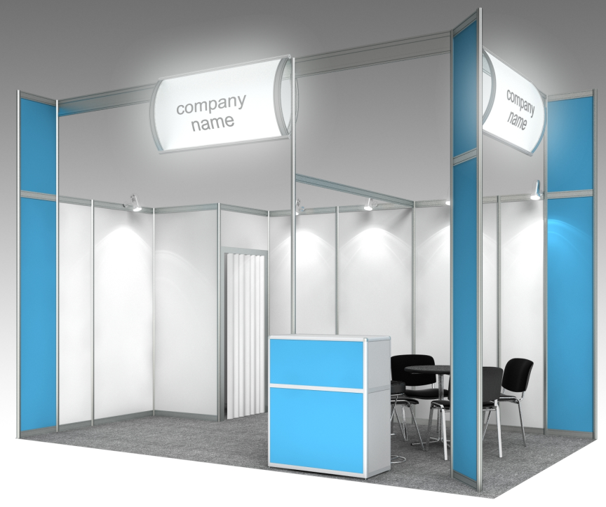

|  |  |  |  |  |  |
| --- | --- | --- | --- | --- | --- |
| **Stand equipment** |  | **6-11** | **12 - 17** | **18 - 24** | **25-32** |
| Carpet (color to choose: gray, blue, red, green) |  |  |  |  |  |
| The height of the stand structures is 3.5 m. the Height of the stand walls is 2.5 m (with partial pasting of the ORACAL film 641) |  |  |  |  |  |
| Utility room with door | sq. m. | no | 1 | 1 | 1 |
| Fascia board with internal illumination (for each open side) | PCs. | 1 | 1 | 2 | 2 |
| Lighting of the total area of the stand. At the rate of 1 spot per 3 sq. m. area. | PCs. | 3 | 5 | 6-8 | 8-10 |
| Triple socket 1 kWt **(in case of payment**  **registration fee)** | PCs. | 1 | 1 | 1 | 2 |
| Information Desk height 1.1 m | PCs. | 1 | 1 | 1 | 1 |
| Round table d-0.7 m, 0,7x0,7, 1,2x0,7m (optional) | PCs. | 1 | 1 | 2 | 2 |
| Chair | PCs. | 3 | 4 | 6 | 6 |
| Waste basket | PCs. | 1 | 1 | 1 | 1 |
| Wall hanger | PCs. | 1 | 1 | 1 | 1 |

**Notes:**

**• Construction of the stand within this offer is possible only from 6 sq. m. of the stand**

**• The color of the vinyl film for pasting design elements is selected by the customer from the standard color scale**

**• It is possible to install equipment that is not included in the standard package, according to the prices for additional equipment**

**• The equipment included in the standard equipment does not change, in case of refusal, the cost is not refundable**