Post-release of the XVII Intourmarket International Travel Fair

From 12 to 14 March the Intourmarket-2022 International Travel Fair was held at the Expocentre Fairgrounds in Moscow.

Official support for the exhibition:
- Government of the Russian Federation
- Federal Agency for Tourism
- Russian Union of Travel Industry (RST)
- Association of Tour Operators of Russia (ATOR)

Event partners:
- Partner regions: the Republic of Khakassia, the Leningrad Region and the Krasnoyarsk Krai
- Partner City: St. Petersburg
- Official partner: the Republic of Bashkortostan
- Interregional partner of the exhibition: Silver Necklace project
- General B2B media partner: Profi.Travel
- General media partner: Vesti.Tourism
- General Internet partner: Turprom
- General news partner: Travel Russian News (TRN)

As part of the official opening of the exhibition Elena Lysenkova, Deputy Head of the Federal Agency for Tourism (Rostourism), delivered a welcoming speech. "This is a special platform which currently gains even more relevance and significance because now industry professionals are lacking space and personal interaction to search for new opportunities, to develop new tourist links, to establish new tourist routes, to create new tour products and offers".
She noted that reconsidering approaches is necessary for the success of the spring and summer season, for increasing the demand for travel to the regions of Russia. "Thanks to platforms like the Intourmarket travel fair all this will be achievable because several thousand professionals who are ready to make the industry more successful, their businesses more effective and tourists happier, have met in one location," added Ms. Lysenkova.
In his turn the Chairman of the Committee of the State Duma on tourism and tourism infrastructure development Sangadzhi Tarbaev reminded that relevant departments are now working on a new law on tourism. "We are now in the process of formulating the legal framework, the rules by which the travel industry will develop over the next 5-10 years. We are waiting for the representatives of the travel industry expertise and opinion on what measures can be introduced as amendments to the draft laws", - he added. Chairman of the Committee also suggested the Intourmarket Fair be held twice a year. "It is very important for us as deputies of the State Duma who are engaged in lawmaking to understand what trends are topical now, what the demands of the travel industry are in order to more accurately formulate draft laws and amendments to the existing laws", - said Mr. Tarbaev.

Also the exhibition opening ceremony was attended by:
- Fatkullin Rinat, Acting Chairman of the State Committee for Tourism of the Republic of Bashkortostan ;
- Voynova Irina, Deputy Head of the Republic of Khakassia;
- Sergey Korneev, Chairman of St. Petersburg Committee for Tourism Development;
- Olga Vasilenko, Acting Head of Tourism Agency of the Krasnoyarsk Krai;
- Golubeva Olga, Deputy Chairman of the Committee on Culture and Tourism of the Leningrad region;
- Litovko Maria, Vice-Governor, Chairman of the Government of Sevastopol;
- Khorokhordin Oleg, Head of the Republic of Altai;
- Osaulenko Aleksandr, Vice-President of the Russian Union of Travel Industry (RUTI), Director of the TOURPOMOSH Association of tour operators in outgoing tourism.

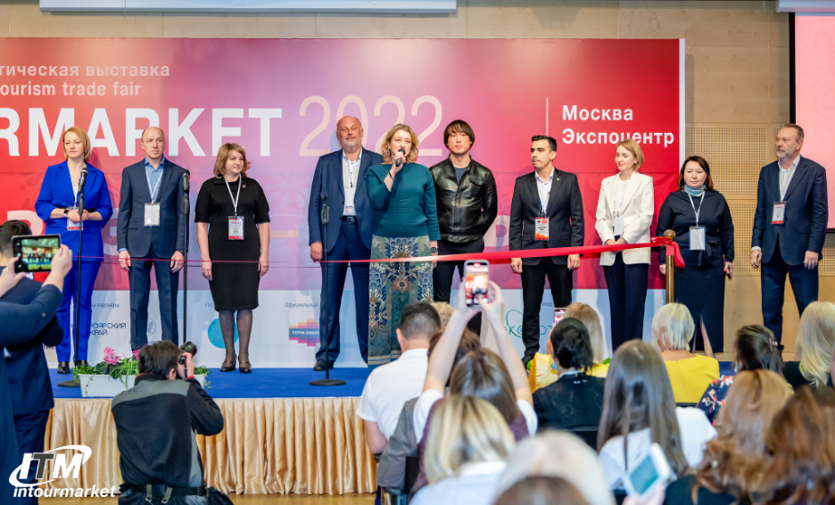
Statistical data of the XVII Intourmarket International Travel Fair

In 2022 more than 720 exhibitors from 14 countries and 71 regions of Russia took part in the Intourmarket International Travel Fair. For three days above 12 650 travel industry specialists visited the exhibition. Over 300 accredited journalists of federal, specialized and regional media gave a full coverage of the event.
The Intourmarket is the only exhibition in Russia which shows the overall tourism product of the country and is "at the peak" of the key tourism trend - import substitution in tourism. The vast majority of regions - from Kaliningrad to Kamchatka – were exhibitors at the Fair. The special feature of this year's edition were the booths of interregional projects: "Silver Necklace", "Imperial route", "Exciting weekend in the Volga region" and "Russia - the country of opportunities". At the same time the foreign countries such as Cuba, the Republic of Belarus and others also exhibited at the Intourmarket. In total, the representatives of 14 foreign countries participated in the exhibition and its business program.
The Intourmarket exhibition was held at the high-profile Expocentre Fairgrounds in a festive environment. At the exhibitors’ booths visitors could obtain information about new tourist destinations and routes, museums and exhibitions, learn about proposals of reliable tour operators and accommodation facilities. Visitors got informed about cultural traditions of Russian regions, took part in master classes, watched thematic installations and performances of folklore groups. They could also take part in raffles for prizes and vouchers, contests and sampling of gastronomic souvenirs.
A special event from the Partnership of Tourist Information Centers (NAITO) in which visitors could receive valuable prizes from the regions of Russia filled the moneybox of vivid impressions: guests took nice selfies at the booths during their visit, answering questions of the quest, getting bonus points and exchanging them for special prizes.

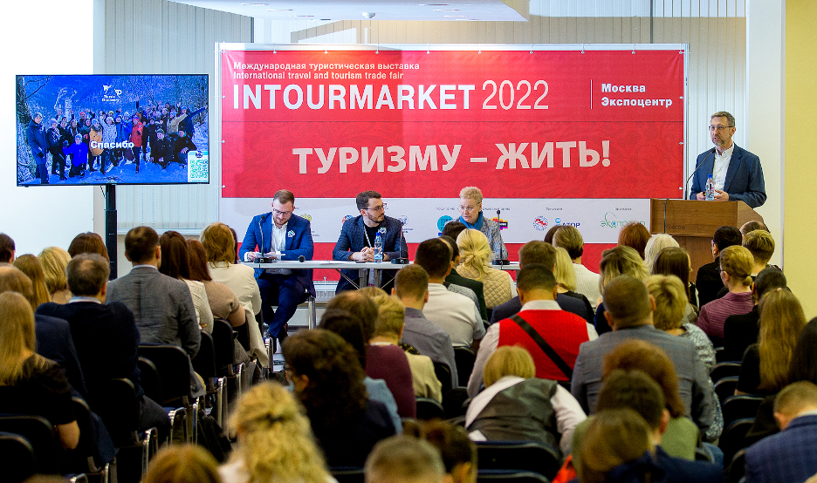Business program results
This year the exhibition boasted an extensive program of business events: more than 60 business sessions with the participation of over 320 speakers took place at six conference halls of the Expocentre. Industry professionals discussed the future of the travel industry in an open dialogue. Presentation discussions introduced new ideas and growing opportunities for business, novel interregional routes and travel projects in Russia, as well as new promising types of tourism - ecological, ethno- and auto-tourism, Arctic, children's, weekend tourism. By tradition events for IT-technologies in tourism were held as well as workshops for tourist information centers and travel journalists. Medical and health tourism readied for rebooting was not overlooked either.
The key business events of the Intourmarket-2022 Fair included:
- Specialized business session: IT-technologies in the Silver Necklace of Russia interregional tourist project
- Business Forum: Tourism, creative codes, creative industries - best municipal practices in Russia
- Workshop: Travel agent's life in the new reality
- Contest of presentations of RUTI regional members: 10 minutes of glory
- Working meeting of regional participants of the Imperial route national tourism project
- Plenary session on topical issues of the industry development
- Training workshop for the regions from the ALEAN national tour operator: Discover Russia with ALEAN. A new look at well-known regions: how to become a sales expert of a regional product
- Creating "More than a journey": the experience of implementing the federal program (2021-2024). Developing new approaches to generating cultural and informative tours
- Presentation of the Primorsky Krai tourist potential with elements of augmented reality
- Conference: An open dialogue with PravTurSoyuz: new trends and challenges 2022
- Practical session: Safety of children's tourism: pain points and possible solutions
- Expert session of the Managing company for tourist and recreational clusters of the Sverdlovsk Region
- Round table on the inter-regional socio-cultural project: Birch letters to the future. XXI century. Great Russian oeuvre of great Russian writers
- Expert round table: We must get cultured: educational tourism and cultural development of cities
- Dialogue platform: Implementing sustainable development mechanisms in tourism and hospitality industry
- Master session: Generation of demand for sustainable tourism products. How to promote to become noticed?
- Meet-up session: Major trends in modern approaches to tourism development in the natural territories
- Media forum:#TimeToTravelForRussia (#ПораПутешествоватьПоРоссии) at the Intourmarket International Travel Fair
- Round table: Modern excursion activities: legal and regulatory framework, educational programs, regional practices and prospects for branded routes
- Seminar: Tourism and the Law. New laws in tourism, challenges and opportunities
- Panel discussion: Development of Arctic tourism in single-industry towns: case study of Monchegorsk (Murmansk Region)
- All-Russian MICE tourism Day
- Panel discussion: The Far East and the Arctic: New opportunities for travel. Summer 2022
- Presentation: Visit Krasnoyarsk Krai. A must see for everyone!
- Presentation: Tourist products of the Baikal region
- Roundtable: Health tourism: emergence, stability or growth? Current trends and products of Russian wellness hospitality
- Interregional charity auction: Travel business with an open heart for the benefit of the children's Hospice
- Final of the V All-Russian Media Tour Contest of journalists and bloggers
- III All-Russian conference: How to attract celebrities to the territory branding
- Presentation: Discover the free Don! All about hospitality and tourist products of the Rostov region
- Conference: From the Black Sea to the White Sea. Auto tourism as a unique instrument for territory development
- Training seminar for tourist information centers (TIC)
- Working meeting of participants and partners of the interregional project: Exciting weekend in the Volga region
- Joint event of the Moscow Tourism Committee and St. Petersburg Committee for Tourism Development: Two Cities - a million impressions
- Practical session on Internet promotion for tourist information centers, museums, regional tour operators and other market participants
- Presentation of travel opportunities in the Kaliningrad region - the westernmost region of the country
- Session: By developing ethno-tourism we preserve cultural code of Russian peoples
- Workshop on excursion bus transportation issues of the RUTI Bus tourism commission
- Round table: Rural and wine tourism in Russia- new impressions, new opportunities for development of tourist business and regions
- Presentation of tourist potential of the Chuvash Republic for Moscow travel industry
- Working meeting of the Russian Union of Travel Industry Commission on river cruises: Navigation 2022. Prospects for cruise tourism development in new economic conditions
- Meeting of the International round table: CIS+World. Professionals’ World 2022
- Intelligent Travel Marketing conference
- Case-session: Educational tourism. Best practices and forms of cooperation
- Workshop: Auto tourists and tourist routes - new blood for the revival of villages and historical settlements

The complete program of the Intourmarket-2022 events can be viewed at https://www.itmexpo.ru/about/program/.

The second day of the Fair was traditionally appointed the Day of MICE tourism and Charity. Within the framework of this day the Travel Business with an Open Heart charity auction with travel, gastronomic and art lots provided by the fair exhibitors was organized. The exhibition and the auction resulted in raising 115,324 rubles for the children's hospice.

The third day of the exhibition this year was the Day of IT-technologies at the Intourmarket which featured the Intelligent Travel Marketing Conference and a practical session on Internet-promotion for tourist information centers, museums, regional tour operators and other market participants.
In 2022 at the Fair the Intourmarket participants signed 19 interregional agreements on cooperation in tourism as well as held 7 working meetings which highlighted the issues of further development of current tourism projects.
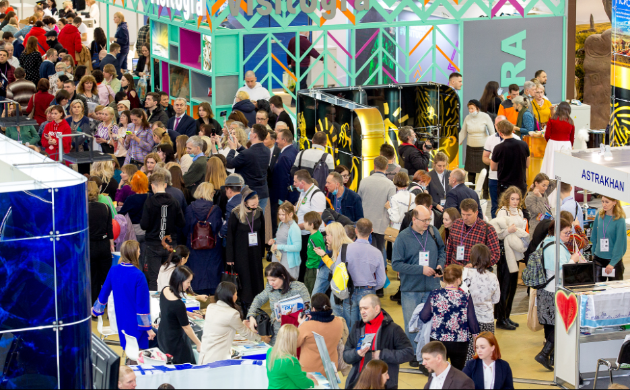
All guests of the Intourmarket-2022 noted the amazing holiday atmosphere at the exhibition and travel industry professionals appreciated the opportunity not only to participate in a close dialogue to discuss concerns but also to find solutions to many pressing issues.
Exhibition organizer: Expotour LTD (Russian Federation)
For more information about the exhibition visit www.itmexpo.ru/.

We welcome you at the XVIII Intourmarket International Travel Fair
on March 13-15, 2023 at Expocentre!

