TECHNICAL GUIDE OF THE EXHIBITOR

XVIII International travel fair
«Intourmarket (ITM)»

Expocentre Fairgrounds, Pavilion 8

Dear exhibitors!

The organizer of the exhibition - the company "Expotour" welcomes You as a participant of our exhibition!

We will be happy to assist you in preparing for the event and answer any questions you may have.

1.Content
1.Content 2
2.Contact information 3
3.Schedule of exhibitions 4
4. Conditions of participation in the XVIII international tourism exhibition «Intourmarket (ITM)» 5
5. Summary application for additional services and equipment 6
6. Application form for publication of advertising 7
7. Application for additional badges for participants, car passes, service personnel 10
8. Application for rent of halls for presentations and seminars 11
9. Stand construction 12
10. The list of documents required to obtain a permit for the production of installation and decoration works in the Expocentre Fairgrounds 15
11. Import of equipment and obtaining permits for installation/dismantling 17
12. The importation of equipment and receipt of passes (for participants) 18
13. Connection of communications to the stand 20
14. Order of suspension of structures inside the pavilion in Expocentre Fairgrounds 21
15. Delivery of goods for foreign companies. 21
16. Security 21
Annex No. 1. Fire safety regulations. 22
Annex No. 2. Rules of performance of electrotechnical works 24
Annex No. 3. Standard equipment for stands 25
Annex No. 4. Application for text and graphic works 29
Annex No. 5. The order form for suspension of structures inside the pavilion 35
Annex No. 6. Builder’s information card 36
Annex No. 7. Standard equipment of stands 37
Annex No. 8. Stand equipment «PREMIUM» 40
Annex No. 9. Carpet colors. 41
Annex No. 10. The color scale of the film ORACAL 641 series 42
Annex No. 11. Value of lost or damaged property 44
Annex No. 12. List of Internet users and consent to the processing of personal data. 45

2.Contact information

The exhibition website www.itmexpo.ru

Exhibition organizer's address:

OOO «EXPOTUR»
101000, Moscow, Myasnitskaya str., 10, p. 1.
tel.:+7- (495) 626-21- 72/73/74, 626- 43- 69

Organizing Committee:
Exhibition Director  Olga Khotochkina  phone: +7 (495) 762-87-65,  itm@itmexpo.ru  Advertising and PR Manager  Ekaterina Gavina  tel: +7 (495) 626- 21- 72/73,  pr@itmexpo.ru  The coordinator of the exhibition  Natalia Ionidi  tel: +7(495) 626 - 43-67  koordinator@itmexpo.ru  Catalog Manager  Natalia Chekanova  nataliec@mail.ru | Sales department:  Sales manager  Kirill Bragin  tel./Fax:+7 (495) 626-21-74  bragin@itmexpo.ru  Sales manager  Irina Smolkova  phone / Fax: +7(495) 626-43-69  smolkova@itmexpo.ru  Sales manager  Marina Zhigunova  phone: +7(495) 626-43-69  marina@itmexpo.ru  Specialists  for international exhibitions  Konstantin Solovyov  phone: +7(495) 626-85-64  konstantin@itmexpo.ru  Technical Director of the exhibition  Andreiy Ivanov  phone: +7 (495) 626-42-74  ivanov@itmexpo.ru

Expocentre Fairgrounds
14, Krasnopresnenskaya nab., Moscow, 123100, Vystavochnaya metro Station.
Fire station No. 160 of the Federal Ministry of emergency situations of Russia in Moscow
tel. +7 (499) 259-13-12
«EXPOCONSTA LLC»
Technical control Department, tel.+7 (499) 795 28 44; +7 (499) 795 39 03 http://expoconsta.com/ru/tehnicheskiy-kontrol/obschaya-informatsiya-i-kontakty/
The company "EXPOCONSTA is conducting a mandatory technical examination of the project of exclusive stand (chargeable service).

Back to table of contents

3.Schedule of exhibitions

Exhibition installation / exhibition Schedule/exhibition dismantling
Friday  March 10 | 8:00-12:00  12:00-20:00 | The layout of the exhibition area  Installation of stands (unequipped area)*  Entrance by mounting passes.
Saturday  March 11 | 8 00-20:00 | Installation of stands (unequipped area)*  Entrance by mounting passes.
Sunday  March 12 | 8:00 – 18:00  08:00 – 19:00  15:00 – 19:30  18:00 – 20:00 | installation of stands  (unequipped and equipped area)*, delivery of exhibits and arrival of participants  Entrance by mounting passes and badges of participants.  Entry of cargo vehicles to the territory of Expocentre Fairgrounds»  Entry of cars into the territory of Expocentre Fairgrounds»  Final cleaning
Monday  March 13 | 08:00 – 10:00  10:00 – 18:00  12:00 | Entrance by participant badges  Delivery of exhibits and equipment  Entry by participant and visitor badges  Exhibition work  Official opening of the exhibition
Tuesday  March 14 | 10:00 – 18:00 | Exhibition work
Wednesday  March 15 | 10:00 – 16:00  16:00 – 20:00 | Exhibition work  Departure of participants / export of exhibits without dismantling of stands in halls  Dismantling of stands
Thursday  March 16 | 8:00 – 18:00  18:00 - 20:00 | Dismantling of stands,  Final cleaning  Pavilions and all halls - must be emptied * * Containers and construction debris must be  exported.
* Prices for additional hours for installation/dismantling Of your stand can be found below, application for services, form 6D, Appendix No. 4.
** After dismantling, the letter for the import/export of equipment must be signed by the hall administrator. If the Exhibitor / Builder leaves the stand / part of the stand after dismantling, the participating company will be charged a fine at the rate of 350 EUR / sq. m + VAT of the stand area.

Please note:

Exhibitors are not allowed to exceed the volume level of 75 dB created by the equipment operating on the stand at the border with adjacent and opposite stands of other participants, and in the open area - within a radius of 5 m. Violation will entail a fine of 780 EUR (excluding VAT), which is imposed immediately. In case of repeated violation the penalty is imposed repeatedly. EXPOCENTRE reserves the right to disconnect the power supply to the offending stand and suspend the removal of the offending Exhibitor's property until confirmation of payment of the fine is received.

Back to table of contents

4. Conditions of participation in the

XVIII international travel fair «Intourmarket (ITM)»

Registration fee: 800 EUR/
(placement in the official catalogue of the exhibition, providing the official catalogue of the exhibition, passes and invitation cards, providing the layout of the stand, connection and use of electricity: when ordering an unequipped area-up to 10kW and when ordering an equipped area 1 socket with a capacity of 1 kW. If the total power of Your appliances exceeds 10 kW-see form 6S.

The cost of unequipped exhibition space for 1m2-340 euro.
The cost of equipped exhibition space, standard, per 1sq.m- 380 euro.
The cost of equipped exhibition space, premium, for 1sq.m - 400 euro.

Extra charge:
* per corner stand (two sides open): + 10%
* for stand "Peninsula" (three sides open): + 15%
* for stand "island" (four sides open): + 20%
* construction of the 2nd floor + 50% of the cost of the reserved area

Back to table of contents

5. Summary application for additional services and equipment
С
Please forward this form to the exhibition management for billing purposes.

Application no. | Description | Description | amount / сумма
Application 2A | Advertising services | Рекламные услуги
 | Advertising in the exhibition catalogue | Реклама в каталоге выставки
 | Advertising in the exhibition guide | Реклама в путеводителе выставки
 | Distribution of promotional leaflets with visitor badges | Распространение рекламной листовки вместе с бейджем посетителя
 | Advertising logos on bags | Реклама на пакете выставки
 | Outdoor advertising in the pavilion and on the territory of the Fairgrounds | Наружная рекламы в павильоне и на территории выставочного комплекса
Application 3, | Services | СЕРВИСНЫЕ УСЛУГИ
 | Badges for exhibitors | Пропуска для экспонентов
 | Parking permits for cars | Парковочные пропуска на автомобили
 | Temporary staff (translators, stand assistants, promoters, etc.) | Временный персонал (переводчики, стендисты, промоутеры и т.д)
 | Information announcement | Информационные объявления
 | Daily cleaning | Уборка стенда
Application 3К | Facilities for individual events | Помещения для отдельных мероприятий
 | Facilities for events | Помещения для мероприятий
 | Equipment for events | Оборудование для мероприятий
Application 5 | Text and graphics, design and decorating of the stand | Текстовые и графические работы, художественное оформление стенда
Application 6А | Additional technical equipment | Дополнительное техническое оборудование
 | Furniture and equipment for the stand | Мебель и оборудование для стенда
 | Equipment for the exhibition area | Оборудование для экспозиционной площади
Application 6В | Additional key elements of design | Дополнительные основные элементы конструкции
 | Kitchenware | Кухонное оборудование
 | Decorative elements | Декоративные элементы
Application 6С | Additional technical services | Дополнительные технические услуги
 | Power supply | Электропитание
 | Plumbing equipment and work | Сантехнические устройства и работы
 | Compressed air | Сжатый воздух
 | Electric equipment | Электрооборудование
Application 6D | Communication and other services | Коммуникационные и прочие услуги
 | Suspension structures on the ceiling of the pavilion | Подвеска конструкций к потолку павильона
 | Prolonged assembling | Продление монтажа
 | Provision of equipment and telecom services | Предоставление услуг и оборудования связи
 | Rental of audio, video and projection equipment | Аренда аудио-, видео-, проекционной техники
 | Equipment for catering | Оборудование для организации питания
 | Catering | Организация питания

This application is a summary table of all orders made by you.
All the above prices include taxes of the Russian Federation.
Ordering and sending it to LLC "Expotour" implies the consent of the Participant to pay for the ordered services in full. The order cannot be cancelled by the customer unilaterally. Any change of the order made earlier, entails its cancellation and registration of a new order at the prices valid at the time of application.
The participant has carefully read the rules of participation in the exhibition set out in this Manual and agrees with them and accepts the provisions of the "General conditions of participation in exhibitions" held "Expotour".

Stamp and sign ____________________ Name _____________________________ date ______________

Back to table of contents

6. Application form for publication of advertising
Contact person:
E-mail: pr@itmexpo.ru
Phone: + 7 (495) 626-21-73
WITHIN
February 15, 2023
(After February 15, 2023, the cost of services increases by 100%).

Contact person _____________________________________________________Tel. ______________________________

Company name (application #1)_______________________________________________________________________

E-mail___________________________________________http://_________________________________________________

ADVERTISING in the OFFICIAL CATALOG (electronic version)
Accommodation of advertising | Mark √ | Cost in EUR
Promotional information on the 2nd cover of the catalog (210 mm x 210 mm) |  | 600
Promotional information on the 3rd cover of the catalog (210 mm x 210 mm) |  | 450
Promotional information on the 4th cover of the catalog (210 mm x 210 mm) |  | 1000
Advertising information inside the catalog-spread |  | 600
Advertising information on a separate page (210 mm x 210 mm) |  | 400
Advertising information on 1/2 strip |  | 250
Advertising at the bottom of the page (sidebar), 12 pages. |  | 500
Company logo next to standard company information. |  | 50
* Exhibition catalogue circulation 5000 copies | TOTAL:

ADVERTISING IN THE OFFICIAL GUIDE AND ON THE EXHIBITION PLAN
Accommodation of advertising | Mark √ | Cost in EUR
Company logo on the exhibition plan + highlighting the stand and the company name in the list of participants in the guide |  | 100
Company logo on the exhibition plan + highlighting the stand and the company name in the list of participants in the guide and on the boards in the pavilion |  | 300
Advertising information on the 2nd page of the cover (210 mm x 297 mm) |  | 1000
Advertising information on the 3rd page of the cover (210 mm x 297 mm) |  | 800
Advertising information on the 4th page of the cover (210 mm x 297 mm) |  | 1200
Advertising information on a separate page (210 mm x 297 mm) |  | 500
Promotional information on 1/2 strip (210mm x 145 mm) |  | 350
* The exhibition guide has a circulation of 25,000 copies | TOTAL:

Advertising on the territory of EXPOCENTRE Fairgrounds (Advertising group No. 8)
Advertising space "a"(40 sq. m) | Mark √ | Cost in EUR
Accommodation of advertising |  | 2130
Advertising space "b" (61.5 square metres) | Mark √
Accommodation of advertising |  | 3420
Advertising space "c"(40 sq. m) | Mark √
Accommodation of advertising |  | 2130
Advertising space "d", "f", "e" (3x4), for 1 place | Mark √
Accommodation of advertising |  | 1050
Advertising space "e"(41,3 sq. m) | Mark √
Accommodation of advertising |  | 2130
 | TOTAL:

Advertising space: «а», «в», «с», «d», «е», «f»

Advertising space «а», «в», «с» | Advertising space «d», «e», «f»
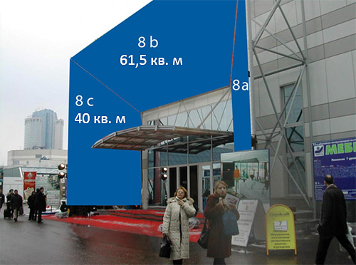 | 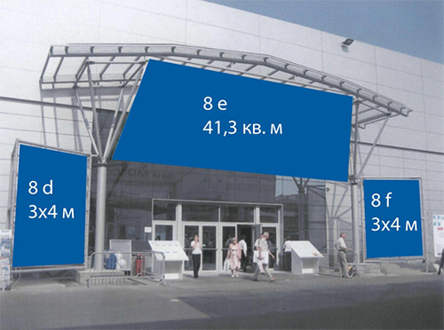

Advertising on the territory of EXPOCENTRE Fairgrounds (Advertising group No. 8)
Rental of advertising spaces on the outer walls of the pavilions, including printing, installation/dismantling of the media, for 1 sq. m. | Mark √ | Cost in EUR
Accommodation of advertising |  | 80
 | TOTAL:

Advertising on the territory of EXPOCENTRE Fairgrounds (Advertising group No. 8)
Rent of mobile modular construction, including printing, installation/dismantling of the carrier, for 1 sq. m (4x2, 4x3, 3x2, 2x2, 1x2, 2x3, 6x3, 6x2) | Mark √ | Cost in EUR
Accommodation of advertising |  | 90
 | TOTAL:

Advertising on the territory of EXPOCENTRE Fairgrounds (Advertising group No. 8)
Rent of surfaces of internal walls and designs of pavilions, including the press, installation/dismantle of the carrier, for 1 sq. m (4x2, 4x3, 3x2, 2x2, 1x2, 2x3, 6x3, 6x2) | Mark √ | Cost in EUR
Accommodation of advertising |  | 80
 | TOTAL:

Advertising on the territory of EXPOCENTRE Fairgrounds (Advertising group No. 8)
Placement of advertising designs of the participant, for 1 PC. | Mark √ | Cost in EUR
Small-sized pillar |  | 115
Roll-up |  | 115
Advertising banner, (not more than 2x2) |  | 335
 | TOTAL:

Advertising on the territory of EXPOCENTRE Fairgrounds (Advertising group No. 8)
Placement of advertising and information coverings on floors and carpets of pavilions, for 1 place of placement (production and installation are included in the rate, the sticker no more than 1 sq. m) | Mark √ | Cost in EUR
Advertising stickers |  | 55
 | TOTAL:

Advertising on the territory of EXPOCENTRE Fairgrounds (Advertising group No. 8)
Rent a typical advertising and information stand at the exhibition, for 1 rack | Mark √ | Cost in EUR
In the visitor registration area |  | 325
In the pavilion |  | 295
 | TOTAL:

You can request additional types of outdoor advertising at CEC "Expocentre" by our advertising Manager

Contact details: +7 (495) 626-21-73, pr@itmexpo.ru
If you order two items, there is a 5% discount, if you order three items there is a 10% discount
Applications with these prices are accepted until February 15, 2023. (after February 15, 2023, the cost of services increases by 100%)
* Attention : Payment should made within 3 working days from the date of placing the application, in rubles, at the internal rate (1 conventional unit (c.u.) = 1 Euro in rubles at the rate of the Central Bank of the Russian Federation on the day of payment +2%).

Stamp and sign ______________________Name____________________ Date_____________

Back to table of contents
3

7. Application for additional badges for participants, car passes, service personnel
Contact person: Natalia Ionidi
E-mail: koordinator@tourfond.ru
Phone: + 7 (495) 626-43-67
WITHIN
February 15, 2023
(After February 15, 2023, the cost of services increases by 100%).
Please send the original to the Organizer. Don't forget to keep a copy for yourself.
The name of the company: |  |  |  |  |  |  |  |  |  |  |  | Country:
Contact person: |  |  |  |  |  |  |  |  | Position:
Phone: |  |  |  | Fax: |  |  |  |  | E-mail:
BADGES FOR EXHIBITORS, PASSES FOR CARS
Service |  |  |  |  |  |  | Price, EUR |  |  | Quantity |  |  |  | Amount, EUR
Additional pass for exhibitors (participant badge) |  |  |  |  |  |  | 12
VIP pass to the Parking lot of cars for the whole period |  |  |  |  |  |  | 170
VIP pass to the Parking lot of cars for 1 day of the exhibition |  |  |  |  |  |  | 55
VIP pass to the Parking lot of cars for the period of installation and dismantling |  |  |  |  |  |  | 70
THE APPLICATION FOR SERVICE STAFF
Service staff |  |  |  |  | Date / Time |  |  | Price, EUR |  |  |  |  | Quantity |  |  | Amount, EUR
Distribution of any advertising and information products outside the stand area is possible only in the presence of the promoter's badge.  Accreditation of the 1 promoter for all days of the exhibition. |  |  |  |  |  |  |  | 210
Stand attendant |  |  |  |  |  |  |  | On demand
Translator | English |  |  |  |  |  |  | 180 / per day
 | European language |  |  |  |  |  |  | 205 / per day
Protection of material assets at the participant's stand |  |  |  |  | Security from 8.00 to 20.00. The minimum time of hiring a security guard is 2 hours. Payment is made according to the rates of Expocentre Fairgrounds. Price on request!
STAND CLEANING
Daily cleaning of the stand is carried out daily, once a day during the exhibition and involves cleaning the carpet floor with a vacuum cleaner, or wet cleaning of the hard floor, cleaning baskets for papers
Cleaning service is available from 8: 00 to 9: 30  Please note the dates on which you need to clean your stand! |  |  |  |  |  |  | March 12 |  |  |  | March 13 |  |  |  | March 14
Wet cleaning of hard floor |  |  |  |  |  | Yes
Vacuuming |  |  |  |  |  | Yes
Type of cleaning |  | Price, EUR |  |  |  |  | Calculation of the cost |  |  |  |  |  |  |  | Amount, EUR.  TOTAL
Vacuum cleaner (carpet) |  | 2 EUR / sq. m for 1 day |  |  |  |  | ______Sq. m x ______days x 2 EUR. =
Wet (laminate) |  | 3 EUR / sq. m for 1 day |  |  |  |  | ______Sq. m x ______ days x 3 EUR. =
THE BROADCASTING OF RADIO ANNOUNCEMENTS

Broadcast on speakerphone, for 1 broadcast: |  | Price, EUR | Number |  | Amount, EUR.
Radio announcements in the open area, up to 30 seconds of sound |  | 28 eur./ PCs.
Radio announcements in one pavilion , up to 30 seconds of sound |  | 20 eur / PCs.
March 12 /  Time and TEXT | March 13 /  Time and TEXT |  |  | March 14 /  Time and TEXT

Attention: Payment is made within 3 working days from the date of placing the application.
Signature of the CEO | name, position

Back to table of contents

8. Application for rent of halls for presentations and seminars
Contact person: Natalia Ionidi  E-mail: koordinator@tourfond.ru  Phone: + 7 (495) 626-43-67 | 3К
WITHIN
February 15, 2023
(After February 15, 2023
, the cost of services increases by 100%).
Please send the original to the Organizer. Don't forget to keep a copy for yourself
The name of the company: |  |  | Country:
Contact person: |  | Position:
Phone: | Fax: | E-mail:

If you want to hold a seminar, presentation, press conference or any other event during the exhibition,
you can reserve the halls located on the territory of Expocentre Fairgrounds.
The organizers of the exhibition are ready to place information about the event in the Business program. To post this information, please provide all necessary information. Such accommodation is at the discretion of Organizers of the exhibition, the text can also be edited or published in an abbreviated version.

Title (theme) and format of the event:_________________________________________________________________________________________________
Date and time of the event:__________________________________________________________________________________________________________
Venue:___________________________________________________________________________________________________________________________

Conference hall | Number of seats | Cost per hour | Conference hall | Number of seats | Cost per hour
Seminar Room #3*  (Pavilion No. 8) | 100 | 555/hour | Hall " Glass Dome"  (Congress Center, 3rd floor) | 150 | 310/hour
Hall " Eastern" *  (Pavilion Forum) | 418 | 495/ hour | Press Room *.  (Congress Center, 2nd floor) | 104 | 310/hour
Hall " Southern"  (Pavilion No. 8) | 200 | 280/ hour | Conference hall *.  (Pavilion 8, 1st floor) | 286 | 250/hour
We book conference room for Х = EUR.
number hall hour price amount

Preferred time from to
* the price of the hall includes a set of sound amplifying equipment (up to 2 wired microphones)
The duration of the planned event should be a multiple of one hour (i.e. 1 hour, 2 hours, etc.).)
Please note that the time is subject to availability and only during the exhibition period from 13 to 15 March 2023.
The use of own equipment (except for personal computers) and technical personnel, as well as the involvement of third parties to provide similar services is prohibited!
Entrance to the conference hall is allowed 10 minutes before the event.
The conference room must be vacated within 10 minutes of the end of the event.
Please note that catering (Banquet, buffet, coffee break, etc.) in the conference halls of Expocentre Fairgrounds is carried out only in agreement with the organizers.

Equipment list | The cost EUR.* | Mark√
Sound amplification equipment kit (up to 2 wired microphones) | 55
Optional wired microphone | 20
Additional radio microphone | 35
LCD projector (1,024 x 768) and screen | 210
Plasma TV 50” | 170
Laptop | 85
The speaker's stand | 85
Presenter | 7
Equipment for simultaneous translation into 1 language (basic and 1 foreign), per 1 hour | Price on request
TOTAL:

* Attention: Payment is made within 3 working days from the date of placing the application, in euro

Signature of the CEO | name, position

Back to table of contents

9. Stand construction

9.1 construction of the stand. Generalities.

The price for ordering unequipped exhibition space includes:
1. Exhibition area
2. One electrical connection up to 10 kW (one connection) when paying the registration fee.
For more information, see section 9, connecting communications to the stand.

The price for ordering the equipped area includes:
1. Exhibition area;
2. Stand as standard complete set (see Annex 7).
The order of additional equipment to a standard complete set is made according to requests 6A, 6B, 6S, 6D (Technical Director Ivanov Andrey-tel.: 8 (495) 626-42-74, ivanov@tourfond.ru)
If you refuse the equipment included in the standard equipment, its cost is not refundable.

Please note that:
1. When installing a mobile stand on the equipped area, this stand must be agreed with the General developer of JSC "EXPOCENTRE", the company EXPOCONSTA, please contact the technical control service tel. +7(499) 795 39 03
2. In case you import banners, drapery fabric or other combustible materials / exhibits, the letter for import/export must be certified by a representative of the fire Department (Fire Department No. 160 Of the CAO GU EMERCOM of Russia in Moscow, tel. +7 (499) 259-13-12). It is necessary to have certificates of compliance with combustibility, smoke formation and toxicity.

9.2 Equipped space / Standard stand:

The standard stand it is the stand constructed of the exhibition structure including a carpet covering, wall panels (color white, h=2,5 m), electric equipment and furniture according to Appendix No.7
Possibilities:
1.Changing the color of the walls by applying a self-adhesive film.
2.Changing the height of the standard stand by building with the use of exhibition structure.
3.Changing the color of the carpet.

The prices for additional equipment for your stand can be found in Appendix No. 4.

Importantly:
Wall elements and other additional structural elements must remain intact after the exhibition and be cleaned from the remnants of adhesive tape, etc. it is Unacceptable to attach your equipment to the stand structures, self-pasting panels, applying logos, drilling holes, attaching advertising and other materials with pins, buttons, hard-to-remove adhesive tape, etc. Otherwise, during the exhibition a damage report will be drawn up, and the cost of the damaged elements of the stand structure and additional equipment will be collected from the participating company.

Please note-it is necessary to comply with fire safety regulations see Appendix No. 1!

9.3 Unequipped exhibition space / Construction of Exclusive stand with another stand
through a third-party developer

The exhibitors can carry out their own work or attract third-party developers to perform installation and dismantling and decoration works only in case of exclusive exhibition stands construction.
Under the exclusive stand is a stand that manufacture by other materials (wood, chipboard, hardboard, fabric, etc.), two-storey stands. Also, exclusive stands can be attributed, made of standart exhibition structures, in the manufacture of which are embodied individual design developments and requires the production of exhibition structures of non-standard type and size.
Pasting panels, applying logos, increasing the height of the walls, the use of suspensions on the stand, electrodynamic structures, remote friezes, etc. additional elements don’t provide the stand into the category of exclusive.
The companies which have ordered not equipped area should pay special attention to the section "fire safety Rules" Appendix No. 1 and "Rules of carrying out electric installation works" Appendix No. 2. These rules should be followed both in the design and construction of your stand. If you have ordered an unequipped area, please provide a copy of the "fire safety Rules" and "electrical installation Rules" to the developers of your stand.
We remind you that the design of your stand must necessarily include a floor covering, rear and side walls with a height of at least 2.5 meters. The stand (parts of the stand) should not go beyond the boundaries of the area occupied by you. It is not allowed to place inscriptions, logos or other information on the parts of your stand facing the adjacent stands. The rear of the stands visible from the aisles and / or adjacent stands must be properly decorated.
When carrying out installation work, it should be remembered that the storage of equipment and materials is allowed only within the leased area.
The use of silicate glass at a height of more than 1.8 m. from the floor level to the upper edge of the installed glass is prohibited. At the specified height, it is allowed to use a special glass type triplex.
The construction of exclusive stands should be made of elements of a high degree of readiness, which have been pre-assembled and painted on the production areas of the Developer. In exhibition halls it is allowed to make only joining of ready elements, sealing and painting of seams with preliminary shelter of floors in passes a protective film. It is strictly forbidden to use stationary circular saws, flat-grinding machines not equipped with a dust pump, open fire, welding. Fastening of elements of stands to walls or a floor is not allowed.
In case of violation of these rules, the installation of the stand may be suspended until the shortcomings are eliminated.
In process of installing a hand-held power tool, it is allowed to use 220 V power outlets on mobile power boards. Connecting the stands to these outlets is prohibited.

After dismantling the stand, the place in the pavilion should remain in its original form (without construction debris, tape, etc.). Otherwise, an act is drawn up, a fine of 310 EUR/sq. m. + VAT is imposed on the participating company.

Importantly:
Before passing the accreditation in EXPOCONSTA, the developer company must provide a package of documents to the technical Department of the exhibition "Intourmarket" , the term of consideration of documents up to 3 working days
(Technical Director Andrey Ivanov-phone: +7 (495) 626-42-74, ivanov@tourfond.ru):

1. Developer information card (page 40 of the Technical manual);
2. The project of the stand (side view, top view) two copies;
3. Letter for the import of equipment;
4. List of installers;
5. The engineering plan of the stand (if it is provided) with the scheme of connection of water, compressed air, suspensions, etc. with full decoding of symbols, certified by the Director of firm;
6. Detailed stand specifying power voltage, maximum capacity load for each unit of equipment, points of connecting electrical equipment with full decoding the symbols, certified by a Director of the company
7. The principal and linear scheme of the electric Board with the indication of loadings, certified by the Director of firm.
8. Power attorney for construction from the participant company

DOCUMENTS ARE ACCEPTED ONLY WITH A FULL SET!

After receiving this information, your copies of these documents are stamped by the technical Department of "Intourmarket", allowing accreditation in EXPOCONSTA.
Without it, documents for accreditation will not be accepted.

Before starting installation, make sure that your stand is located in the appropriate place and corresponds to the square footage of the project. Otherwise, if the location of your structures relative to the General layout is inaccurate, you will have to dismantle and re-install the stand at your own expense.

9.4 Construction of a two-storey stand

During the construction of a two-storey stand, it is necessary to coordinate the documents in the company "EXPOCONSTA", no later than 45 working days before the start of installation work at the exhibition.

Primary structure:
- power two-storey structure must have a static calculation of the carrying capacity;
- the podium under the stand must withstand a load of 500 kg / m2;
- the parts of the podium that take the load of the supporting structure of the two-storey stand must withstand 2500 kg / m2;
- the floor of the second floor must withstand a load of 350 kg / m2;

Enclosing structures of the stand:
- enclosing structures of the second floor must have a height of at least 1100 mm from the floor level of the second floor and prevent the possibility of falling of various objects;
- the enclosing structures of the second floor must withstand a lateral load of 100 kg / m2;
- walls of the second floor in which easy fillings are used shall have rigid safety filling at the height of 1100 mm from the floor level of the second floor and maintaining lateral loading of 100 kg;
- backlash swing walls, railings and frames should not exceed 5mm.

Staircase:
- the main staircase of the stand can only be a flight of stairs, application
a spiral staircase is possible as an auxiliary stairs;
- the width of the flight ladder must be at least 900 mm;
- the load perceived by the ladder should be 500 kg / m2;
- width of steps of a ladder not less than 250 mm;
- the angle of inclination of the ladder is not more than 36° from the horizontal axis;
- at height of lifting of a ladder more than 450 mm it is necessary to provide a protection with a handrail;
- the stair railing shall have a height of 1100 mm and withstand a lateral load of 100 kg.

Stand decoration:
- when designing the stand, the use of silicate glass at a height of more than 1800 mm from
floor level of the hall to the upper edge of the installed glass is prohibited;
- for the design of the stand of silicate glass is used a special glass-triplex;

Fire protection requirements:
- at design of two-storey stands it is necessary to carry out requirements of fire safety according to the current norms and rules; see Appendix No. 1.
- the two-storeyed stand without fail is equipped with sensors of the fire prevention notification with an output of a signal to the corresponding services and the fire extinguisher.

Back to table of contents

10. The list of documents required to obtain a permit for the production of installation and decoration works in the Expocentre Fairgrounds
for independent developers.

To installation works are allowed organizations that have signed a contract with the General developer of Expocentre Fairgrounds - LLC EXPOCONSTA. http://www.expoconsta.ru , The Department of technical control, tel. (499) 795 39 03
Permission is given based on the results of the examination of technical documentation of the stand, performed on a commercial basis.
The cost of the work is determined in accordance with the price list of LLC "EXPOCONSTA".
Prices for the cost of works, services are determined subject to the submission of technical documentation and documents for the right to work:
15 days before the start of installation work at the exhibition (event) for single-storey stands;
45 days before the start of installation work at the exhibition (event).
When submitting documentation within 15 to 3 days (for a single-storey stand) and 45 to 15 days (for a two-storey stand) before the start of installation, the cost of work performed, services provided increases by 50%. If the documents are submitted within less than 3 days (for a single-storey stand) and from 15 to 6 days (for a two-storey stand) before the start of installation work, the cost of the work increases by 100%.
For the examination it is necessary to submit the following documents to EXPOCONSTA LLC:
a) Certificate of conformity to the requirements of GOST R ISO 9001 in relation to the design, construction of exhibition stands, works on the device of power supply up to 1000 volts (notarized).
b) power of attorney from the Exhibitor's company for the construction of the stand;
C) a letter with the name of the company for which the construction of exhibitions is carried out, with a list of equipment and materials to be imported and exported.
d) the project of the stand executed in isometry and certified by the Director of firm;
f) a detailed exposition plan of the stand specifying total construction area certified by the Director of the company;
e) detailed electrical design of the stand indicating voltage, maximum capacity load for each unit of equipment, points of connecting electrical equipment with full decoding the symbols, certified by the company Director (all metal booth structures, electrical panel, metal hose, metal tubes of wiring, etc. must be grounded);
g) the engineering plan of the stand, if it is provided by the Exhibitor, with the scheme of connection of water, compressed air, etc. with the full decoding of symbols, certified by the Director of firm;
h) certificates of conformity for the materials and equipment used (combustible materials must be treated with appropriate refractory compounds, the use of combustible materials without appropriate treatment is prohibited);
j) certifications for load-bearing structures for 2-storeyed stands;
- static calculation for power structures of 2-storey stand with the attached positional plan of structural elements;
- drawings of two-storey booth in a 1:100 scale, with dimensions and types of sections signed by the designer and stamped by the organization that performed the project of the stand.
In case of absence of statistical calculations, LLC EXPOCONSTA carries out calculations by own forces, on a commercial basis (according to rates of LLC EXPOCONSTA).
k) the list of electricians not lower than the 3rd group of the admission participating in electrical installation works on the stand and copies of their certificates certified by the Director of firm;
l) a copy of the order on appointment of the responsible person not lower than the 4th access group, responsible for the installation/dismantling of electrical equipment at the stand, and the appointment responsible for carrying out mounting/dismantling works and safety at the stand signed by the Director;
m) a copy of the electricians knowledge test log certified by the Director of the firm;
n) a list of assemblers with full passport information who are participating in the Assembly/dismantling operations at the booth certified by the Director of the company. For citizens of foreign countries in their passport should be a visa of the Russian Federation. Employees engaged in the installation/dismantling of the stand must have a residence permit (valid registration) in Moscow or the Moscow region;
o) insurance policy for the listed installers;
p) permission of Fire Department No. 160.

Entrance of transport to the territory of Expocentre Fairgrounds

Entry of vehicles for the organization of import / export of exhibits and equipment to the pavilions of "Expocentre Fairground" is carried out on the passes received in the administration of Your pavilion on the basis of a letter of import / export. After unloading the exhibits and equipment, the transport should be taken out of the complex.

Back to table of contents

11. Import of equipment and obtaining permits for installation/dismantling
for independent developers

Relevant documents:

1. Letter in 4 copies on the letterhead of your organization with a list of imported equipment, indicating the number of the stand, the name of the Exhibitor company, the size of the ordered area (in square meters), the letter must be signed by the General Director and the seal of the organization.
2. A letter in 4 copies on the letterhead of your organization with a list of employees engaged in the installation/dismantling of the stand indicating passport data and valid registration in Moscow or the Moscow region (for foreign citizens in the passport must be a visa of the Russian Federation).
This letter must be certified in fire station No.160 and EXPOCONSTA company.
1. Power of attorney for the construction company from the Exhibitor company for the right to build the stand of this company.
Letters for import / export of equipment must be signed:
1. in the technical Department of the exhibition "Inturmarket" (Technical Director Andrey Ivanov-tel.: 8 (495) 626-42-74, ivanov@tourfond.ru);
2. in the Fire Department No. 160, in the company "EXPOCONSTA", the Director of the exhibition from the Expocentre.
3. in the company "EXPOCONSTA", technical control Department, tel. (499) 795 39 03, Fax (499) 795 28 44 the company "EXPOCONSTA" necessarily carries out technical expertise of the stand project (paid service).
4. The letter for import/export, as well as the list of employees for installation/dismantling, is vised to the exhibition Directorate by «EXPOCENTRE».
5. The letter of import/export, signed in the Directorate from Expocentre JSC, serves as the basis for issuing a car pass for the import/export of equipment and exhibits to the administration of Your pavilion.
6. The signed letter with the list of employees serves as the basis for issue of passes on installation/dismantle.

IMPORTANT: unloading / loading takes 1 hour, starting from the time specified in the pass on the machine.
IMPORTANT: the use of mechanized vehicles (including vehicles equipped with load-lifting manipulators) and personnel of other organizations is prohibited. Official freight forwarder is a company ZAO "EXPOWESTRANS" (see paragraph 11 delivery of goods).

Back to table of contents

12. The importation of equipment and receipt of passes (for participants)

The procedure for registration of documents upon arrival at the exhibition on March 10, 2023:
1. The representative of Exhibitor, having the 3 copies of Letter for entry/removal of equipment (D. 03 form) and 3 copies of power of Attorney (form D. 01 or D. 01a) the representative of the company issued on letterhead with stamp and signature, receives a one-time vehicle pass to check the machine for delivery of exhibits. Passes (a) are issued free of charge. Be ready to tell the number of the car and show your passport. You can get a car pass from the ADMINISTRATION of Your pavilion - with a letter for import/export (form D. 03) and a power of attorney (form D. 01 or D. 01a) the Exhibitor goes to the administrator of the pavilion and he is issued a pass. Samples see the Letter on arrival.
Entrance to the territory of Expocentre representative of the company either on a permanent name badge of participant (the participant's badge) or by writing a one-time pass at the pass Office from the side of 1st Krasnogvardeysky proyezd or Krasnopresnenskaya embankment (for one-time passes you should have a Letter for a single pass (see the Letter on arrival), a passport and a power of attorney (D. 01 form)).
2. After receiving the car pass, the car enters the territory of Expocentre Fairgrounds. When crossing the checkpoint, it is necessary to make an appropriate mark on the letters of entry and pass the inspection of Your vehicle for safety, then proceed to the place of unloading/loading. Registration of letters for import/export in the Administration of your pavilion and the mark "entry/exit allowed" are MANDATORY.
Entry to Pavilion 8 is carried out through checkpoint No. 2 from the 1st Krasnogvardeisky passage
- by truck from 08: 00 to 19: 00,
- passenger vehicles from 15: 00 to 19: 30
3. Unloading / loading takes 30 minutes, starting from the time specified in the pass to the machine. Immediately after unloading/loading of exhibits and equipment, the transport must leave the territory of the exhibition complex.
4. The use of mechanized vehicles (including vehicles equipped with load-lifting manipulators) is prohibited.

Please note!
1. When importing radio-electronic and high-frequency devices, including Wi-Fi access points, into the territory of the Expocentre, it is necessary to pass the approval in advance or on the day of arrival in the technical service of Expocentre. The penalty for unauthorized importation is 23,600 rubles (excluding VAT). Contact phone for inquiries on the issue of approval of the import of equipment: tel. (499) 795-37-78.
2. LLC «Expotour» reminds of necessity of observance of "General conditions of participation in exhibitions", in particular, sanitary norms on noise level. Therefore, to conduct shows and presentations using sound-amplifying equipment, it is necessary to obtain the permission of the Organizer and provide the program of the event. During the planned event, it is forbidden to exceed the volume level on the borders of the stand of 75 DB. Violation of sanitary standards for noise accompaniment of stands entails penalties in the amount of 50 000 rub. (excluding VAT). The fact of violation is fixed by the act. The fine shall be imposed immediately. In this case, the Organizer has the right to turn off the power supply of the violator's stand and / or suspend the export of the violator's property until confirmation of payment of the fine is received.
3. When installing a mobile stand on the equipped area, this stand must be agreed with the General developer of JSC "EXPOCENTRE", the company EXPOCONSTA, please contact the technical control service tel. +7(499) 795 39 03
4. In case you import banners, drapery fabric or other combustible materials / exhibits, the letter for import/export must be certified by a representative of the fire Department (Fire Department No. 160 Of the CAO GU EMERCOM of Russia in Moscow, tel. +7 (499) 259-13-12). It is necessary to have certificates of compliance with combustibility, smoke formation and toxicity.
5. For the organization of loading and unloading operations with the use of equipment on the territory of the Expocentre, You can contact the official forwarder of the Expocentre Fairgrounds-Expovestrans LLC at the address: Moscow, Krasnopresnenskaya Embankment, 14, p. 2, COMT. tel.: +7 (495) 605 74 21, +7 (495) 605 03 27, e-mail: exhib@ewt.ru website: www.ewt.ru
Requirements for exhibits:
If the cargo in addition to exhibits contains structural elements of the stand (wall panels, carpet, decorative structures and elements, etc.), it is necessary to pass the approval of the import to EXPOCONSTA LLC and the Fire Department No. 160 Of the CAO of the EMERCOM of Russia in Moscow.
tel. LLC "EXPOCONSTA": +7(499) 795 39 03, e-mail: sales@expoconsta.ru; www.expoconsta.ru
Fire Department No. 160: +7(499) 259-13-12 (entrance between pavilions No. 2 and No. 8, on the lower level)
Fire protection of the complex strongly objects to any kind of storage (containers, packaging, boxes, building materials) on the stand and fines upon detection.

Back to table of contents

13. Connection of communications to the stand

The registration fee includes: when ordering an unequipped area-up to 10kW and when ordering an equipped area 1 socket with a capacity of 1 kW, if you need power over 10 kW or additional connection, you must contact the technical Department of the exhibition "Intourmarket" (Technical Director Andrey Ivanov - tel.: +7 (495) 626-42-74, ivanov@tourfond.ru), the service is paid additionally, see Appendix No. 4, application 6S.
Please note that the prices are for connection to 1 electric switchboard. In the presence of 2 or more boards the cost of connection is calculated separately for each electric switchboard.
The stand shall be equipped with the electric switchboard corresponding to power consumption, with RCD (the device of protective shutdown) and an input electric cable (flexible, copper, five-core, section not less than 6 mm) calculated on power consumption and sufficient length (about 30 m.p.).
The electrician who is carrying out installation of electric equipment on the stand shall have group of the admission not lower than 3.
After completion of electrical work is measured resistance wiring (The service is paid additionally, please contact LLC "EXPOCONSTA"). After that, the stand is connected to the power supply.

If you need to connect / drain water, one-time water inlet, suspension or additional electricity (see application for additional equipment form 6S/6D), please contact the technical Department of the exhibition "Intourmarket" (Technical Director Andrey Ivanov-tel.: +7 (495) 626-42-74, ivanov@tourfond.ru)

Back to table of contents

14. Order of suspension of structures inside the pavilion in Expocentre Fairgrounds

1. For independent developers-please contact LLC "EXPOCONSTA", contact person Gromov Nikita, tel. +7 (499) 795 39 03, Fax (499) 795 28 44, gromov@expoconsta.ru. The service is paid additionally (according to the price list of EXPOCONSTA LLC).
2. For participants-please contact technical Department of the exhibition "Intourmarket" (Technical Director Andrey Ivanov-tel.: +7 (495) 626-42-74, ivanov@tourfond.ru).
3. Order form for suspension structures inside the pavilion (issued on the letterhead of the organization), Annex No. 5;
4. Drawing of the suspended structure (issued on the letterhead of the organization);
5. Stand design, top view of the stand indicating the dimensions of the suspended structure and indicating the design load on each point (issued on the letterhead of the organization);
6. Application for additional equipment, form 6D, Annex No. 4

Without the above original documents, the order for the suspension will not be accepted.

15. Delivery of goods for foreign companies.

Official forwarding agent of JSC "EXPOCENTRE" are the firm "EXPOWESTRANS".
123100, Russia, Moscow, Krasnopresnenskaya nab., 14, p. 2
Tel.: +7 (495) 605-55-50, (495) 605-03-27
Fax: +7 (495) 605-79-35
e-mail: ewt@ewt.ru ; website: http://ewt.ru/

Loading and unloading services for foreign exhibitors can be ordered only by the Company's Official forwarders.

16. Security
Please note that during the installation, operation and dismantling of the exhibition is taken under protection from 20.00 to 08.00 the next day.
From 8.00 to 20.00 the Exhibitor is responsible for the safety of the exhibits. We strongly recommend that you DON’T LEAVE valuables, documents and money unattended during the exhibition. In case of need for personal protection of Your stand in the morning from 8.00 to 10.00 or in the evening from 18.00 to 20.00, we ask you to place an order timely-application form 3, or provide for the presence of employees at the stand at this time. Security service is paid and paid, according to the rates of Expocentre Fairgrounds, the minimum time of hiring a security guard is 2 hours.
17. Cleaning Service
During the installation/dismantling of the exhibition, every day of the exhibition, there is a cleaning of aisles (small debris).
Every morning, before the opening of the exhibition for visitors, the AISLES between the stands are cleaned. Garbage left by You the day before, in front of the stand, should be Packed in a plastic bag. Stand cleaning is not included in the stand price.
Keeping the stand clean is provided by the Exhibitor himself. If you need cleaning of the stand, you can order it in advance by making an Application-3 before 15 February 2023.

Back to table of contents

Annex No. 1. Fire safety regulations.
Fire safety rules established on the territory of the exhibition complex.

1. The exhibition management provides for the exhibition pavilions (premises) in good condition, guarantees the basic conditions of fire safety, taking into account building regulations.
2. Exhibitors are responsible for fire safety and compliance with fire prevention measures during the installation, operation and dismantling of fairs and exhibitions.
3. Control over the implementation of these rules is carried out by the exhibition Directorate and local fire authorities.
4. Participants of the exhibition in advance, but not later than a month before the start of installation work, are required to provide THE fire Department of the Expocentre Fairgrounds (Fire Department No. 160 Of the CAO of the EMERCOM of Russia in Moscow) with information about all radioactive, fire and explosive materials and exhibits to take appropriate coordinated safety measures. Import of the above materials and exhibits without the permission of Expocentre Fairgrounds is not allowed.
5. The fixed structures of stands may be manufactured of conventional building materials (of a normal Flammability class). For the decoration of stands, offices, podiums, ceilings and fences, fireproof and hard-to-burn materials should be used. All combustible materials must be treated with a flame retardant. Application of drapery materials from the combustible plastics which are not amenable to processing by a fire-retardant structure is not allowed. The use of combustible synthetic finishing materials on the escape routes (in halls, lobbies, corridors, stairwells) is prohibited. All materials used in the construction of the stand must be provided with documentation describing the degree of combustibility of materials.
6. Carpets and carpets used in pavilions should be firmly attached to the floor around the perimeter and at the joints. They must be made of a highly flammable material (do not catch fire from a burning cigarette or match).
7. During the period of installation and dismantling of exhibits, the approach ways in the pavilions (halls) should be free. Used transportation boxes, packing and similar materials and equipment must be removed immediately from the pavilions.
8. On the ways of evacuation and movement of visitors it is forbidden to arrange thresholds and turnstiles. Passageways for visitors must be at least 3 meters and provide ring traffic, as well as free access to evacuation passages, electrical panels, fire cabinets and other fire extinguishing means. Stairwells, evacuation exits, passages, corridors, vestibules must be kept free from any objects that impede the movement of people.
9. In the case of fire cabinets or electrical panels located on the territory of the exhibition stand, free access to them must be provided (decorative curtains or other drapery that does not prevent instant access is allowed). With such masking of fire cabinets, it is necessary to use a special symbol "PC" (applied to the curtain or drapery, must be clearly distinguishable from the aisle).
10. To arrange in the stairwells and under stair flights expositions made of flammable materials, and lay out offices and service rooms shall be prohibited.
11. The use of electric and gas appliances for making tea and coffee can be allowed only in rooms specially designated and equipped for these purposes.
purposes in coordination with fire protection. Electric heaters, refrigerators, air conditioners must be connected to an independent power supply with a starting protective device.
12. On exhibition stands it is forbidden:
• to set up storerooms and workshops
* storage of flammable and flammable liquids
• to install containers with easily flammable gases.
* demonstration in action exhibits using open fire.
13. If the permissible current in low-power electrical devices (electric motors, transformers, etc.) installed on the electrified stand is lower than the calculated one on which the protective circuit breaker is installed, it is necessary to provide additional electrical protection. All electrical installations must be grounded. It is necessary to have acts of insulation resistance, which must be provided to the Fire Department number 160. Management of CAO GU EMERCOM of Russia in Moscow (entrance between pavilions number 2 and number 8).
14. When laying power grids open, if there is no danger of mechanical damage, it is allowed to use cables with fireproof or hard-to-burn outer shell. All connections and branches of wires and cables must be performed by welding, soldering, crimping or special clamps. At the junctions and branches, the cores of wires and cables must be reliably isolated.
15. Flexible wires protected from mechanical damage must be used to connect mobile current collectors. Upon consolidation of wiring articles (terminal boxes, sockets, etc.) on flammable or difficult to ignite the ground under them should be laid a layer of asbestos.
16. For lighting of halls and stands electric luminaires in relation to fire rooms of class P II shall be used. The use of diffusers made of organic glass, polystyrene and other flammable materials in lamps is not allowed. The distance from the lighting fixtures to fireproof or hard-to-burn surfaces should be at least 40 cm.
17. In the exhibition hall, the demonstration of existing models and installations operating on flammable liquids or combustible gases is permitted only if their pipelines are supplied from a tank installed outside the building and exhaust gases are discharged outside. Installation and demonstration of exhibits and processes related to the possibility of fire (welding and soldering works, other types of work related to open fire, flammable solvents, etc.) are subject to agreement with the fire service. (Fire Department No. 160 of the CAO GU EMERCOM Of Russia in Moscow, tel. +7 (499) 259-13-12).
18. It is not allowed to place warehouses of advertising materials and representative goods in the exhibition hall. In the premises of offices it is allowed to store them in quantities,
not exceeding the daily requirement. Storage of exhibits, spare equipment, containers and packaging materials should be carried out outside the pavilions or in specially designated areas.
19. Smoking in the exhibition halls is allowed only in specially designated areas for this purpose, agreed with the fire protection.
20. Welding and other flammable works must be carried out only with the written permission of the exhibition Directorate in strict compliance with the applicable fire safety rules.
21. All other issues not covered in these rules and arising during the installation, operation and dismantling of the exhibition, are resolved on the spot by fire protection specialists.
22. If the design of the exhibition does not comply with these rules, the exhibition management has the right to require the participant to dismantle the exhibition.
23. Every day after the end of the working day all pavilions, administration offices and other premises, halls, lobbies, etc. must be cleaned of combustible debris and materials. It is necessary to de-energize electrical appliances, except for refrigerators and equipment involved in the continuous technological process. Garbage is taken out in special containers.
24. All exhibitors must know and comply with fire safety measures, be able to act in the event of a fire and use primary fire extinguishing means.

For violation of fire safety rules to the participants of the exhibition, including representatives of foreign companies, the bodies of state supervision in accordance with the established procedure apply penalties in accordance with the Laws of the Russian Federation.

Back to table of contents

Annex No. 2. Rules of performance of electrotechnical works
Rules of performance of electrotechnical works established in the territory of the exhibition complex.
1. To carry out electrical work, you must have a License for the right to carry out the relevant work.
2. All electrical work must be carried out in compliance with the current "Rules of technical operation of electrical consumers" ; "safety Regulations"; "Rules of the device of electro installations"; "The rules of fire safety in the Russian Federation and Construction norms and rules". At the same time, it is necessary to fulfill special requirements due to the peculiarities of exhibition events.
3. Each independent electrical installation (stand, electrical unit, etc.) must have a separate device for protection against short circuit and overload (electrical Board and PSD - protective shutdown device) with a calculated setting for the actuation current. This unit must be installed in an accessible location at a height of 1.8 m from floor level.
4. All electrical work on the stands of individual developers should be carried out under the supervision of an electrician with a category of tolerance not lower than the third. Before connecting the stands to the power supply of the EC, an act of checking the insulation resistance is submitted and an act of delineation of responsibility is signed.
5. All electrical panels required for internal power distribution on the stands of individual developers must be equipped with a protective shutdown device (PSD). The power cable from the electrical Board of the stand to the point of connection to the power grid of the EC is provided by the developer. Mandatory requirement to cable-the availability of 5 core, flexible, copper, a long not less 30 run. m, section 6 mm.
6. The feeding electric cable from an electric bar to the protection device shall be protected from mechanical damages (it is placed in a pipe, a metal sleeve, a casing, etc. with the subsequent fastening).
7. Connections of branches of core of wires and cables should be carried out by hot soldering (welding) or by using of bolt clamps. Connection by using of a twist, and also increase (extension) of an electric wiring by using of terminal blocks is not allowed.
8. All metal structures of the exposition (stand), the body of electric boards, metal sleeves, metal pipes of electrical wiring, etc. must be grounded.
9. Connection of the stand is carried out only if the above requirements are met.
10. Since personnel access to electrical installation works, control over compliance with personnel safety requirements rests with the representatives of mounting organizations.

Back to table of contents

Annex No. 3. Standard equipment for stands

Additional equipment for stands must be ordered and paid for
no later than February 14, 2023.
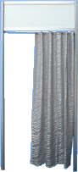  Curtain | 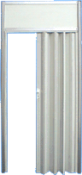  Sliding door | 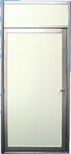  Swing door
Wall element with glass | 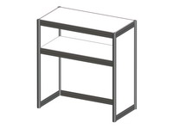  Direct element of information desk 1000х500х1100 м. | 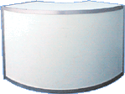  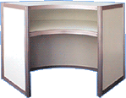  Radius element of information desk R-1m
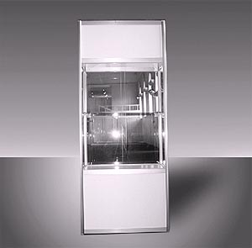  Showcase 1000х500х2500 | 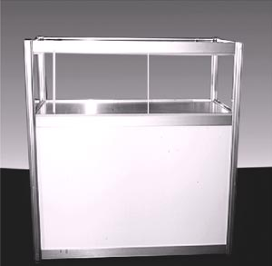  Showcase 1000х500х1100 | 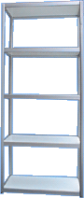  Built-in rack 5 shelves  1000x500x2500

Back to table of contents
Additional equipment for stands must be ordered and paid for
no later than February 14, 2023.

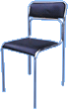  Chair | 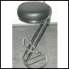  Bar chair | 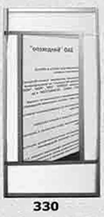  Mirror
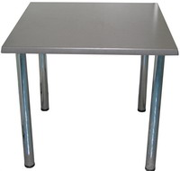  Table 800х800 | 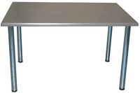  Table 800х1200 | 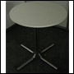  Table D-0,8 H-0,8
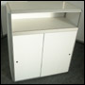  Cabinet; h-1,1 | 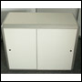  Cabinet; h-0,8 | 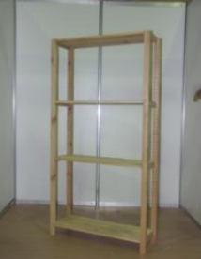  Modular rack 1000х300х2070
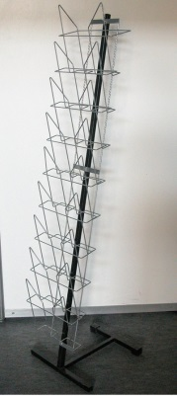  Prospectus holder  Z-shaped | 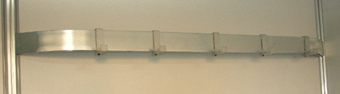  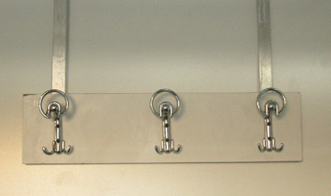  Hanger | 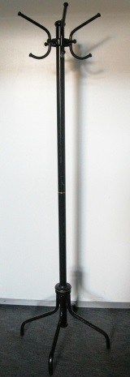  Floor hanger

Back to table of contents
Additional equipment for stands must be ordered and paid for
no later than February 14, 2023.
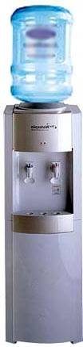  Water cooler  (hot / cold water) | 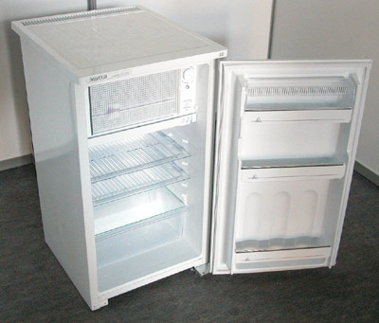  Refrigerator 120 L | 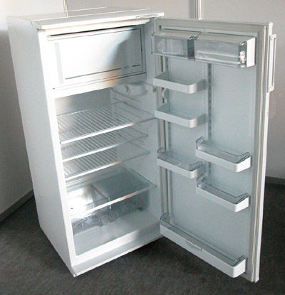  Refrigerator 240 L

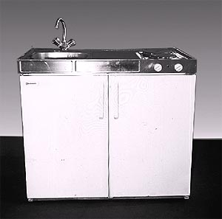  kitchen unit (sink, stove, refrigerator) | 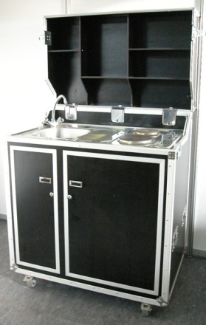  Kit Kase  (sink, stove, refrigerator) | 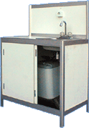  Sink (hot / cold water)
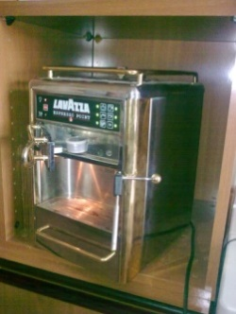

coffee machine

Back to table of contents

Additional equipment for stands must be ordered and paid for
no later than February 14, 2023.
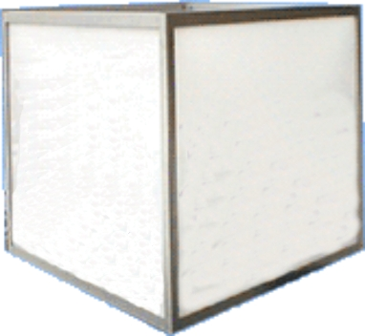  Cube with inside illumination | 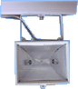  Halogen spotlight  300 W | Spot wall lamp on the busbar 100 W
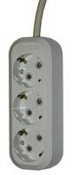  220V triple socket, consumption not more than  1.0 kW | 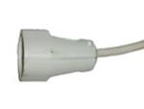  220V socket, consumption not more than 1.0 kW | 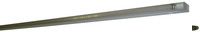  Fluorescent lamp  40 W

Back to table of contents

Annex No. 4. Application for text and graphic works
5

Company name: |  | Contact  Person:
The cost of works and materials from February 14, 2023 increases by 50%.
The cost of works and materials from February 24, 2023 increases by 100%.
The application must be sent electronically.
If you have any technical questions, please contact Andrey Ivanov -
phone: 8 (495) 626-42-74, ivanov@tourfond.ru
FRIEZE INSCRIPTION.
STANDARD-20 CHARACTERS, FONT “HELVETICA", BLUE,
HEIGHT of LETTERS 100mm. ONLY THE NAME OF THE COMPANY
Please fill out the form in BLOCK LETTERS
Symbols included in the standard equipment of the stand
Additional symbol 1.5 euro per sign

Additional inscription no more than 20 characters (only for the frieze panel!)

SERVICES FOR THE DECORATION OF THE STAND
* Orders for graphic works cease to be accepted 14 days before the start of installation of the exhibition.

The logo must be submitted to the technical Department in vector format in CorelDraw (version not higher than 13.0).
Logo production on the frieze panel (up to three colors size not more than 1x0. 3 meters) | PCs. | 70 euro
Production of a logo on a cube (up to three colors the size no more 1x1 meters) | PCs. | 125 euro
Inscriptions on the wall panel (font Helvetica up to 100 mm) Color to choose from the palette ORACAL 641 series) | (maximum 9 characters) | 65 euro
Full color printing (including work on pasting) | (layout of the customer) per 1 sq. m | 55 euro
Banner on grommets (including mounting) | (layout of the customer) for 1 sq. m. | 40 euro
Pasting panels with film Oracal 641 series or  customer's full color printing | 1 sq. | 35 euro

Attention: Payment is made within 3 working days from the date of placing the application.

Stamp and signature ____________________ Name _____________________________ date ______________

Back to table of contents

Annex No. 4. Application for additional equipment
6А
The cost of works and materials from February 14, 2023 increases by 50%.
The cost of works and materials from February 24, 2023 increases by 100%.
The application must be sent electronically.
If you have any technical questions, please contact Andrey Ivanov – phone: 8 (495) 626-42-74, ivanov@tourfond.ru
Company name: |  | Contact  Person:

No. | Name | Description |  | Cost,euro* | Number | Amount, euro*

Furniture and equipment for the stand
101 | Table | 0,7 м x 1,4 м |  | 65
102 | Table | 0,7 м x 0,7 м |  | 55
103 | Round table D 0.7 m | H 0,8 м |  | 70
106 | Chair |  |  | 25
107 | Bar stool | 45 |  | 45
108  109 | Cabinet (without lock) | H 0,7 м  H 1,1 м |  | 75  90
1091 | The lock for Wardrobe-cabinets | Issued in the Organiser’s office |  | 25
110 | Wooden rack 4 shelves | 0,2 m x 0,83 m H=2,08m. |  | 55
1101 | Rack, 4 shelves | 500х1000 Н=2, 5m. |  | 115
111 | Wall hanger |  |  | 20
1111 | Floor hanger |  |  | 60
1121 | Prospectus holder Z-shaped |  |  | 60
114 | Trash |  |  | 5
116 | Mirror |  |  | 50

Equipment for the exhibition area
300 | Wall shelf for 1 linear metre |  | linear metre | 25
301 | Stand for exhibits H = 0.5 m |  | 1х0,5 | 50
304 | Stand for exhibits H = 0.75 m |  | 1х0,5 | 55
307 | Stand for exhibits H = 1,1 m |  | 1х0,5 | 60
310  311 | Corner element of information desk H 1, 1 |  | R 0,5 м  R 1,0 м | 105  125
312  313 | Straight element of information desk H 1, 1 |  | 0,5 м x 1,0 м  0,5 м x 0,5 м | 85  75
314  315 | Showcase H = 1.1 m |  | 0,5 м x 1,0 м  0,5 м x 0,5 м  1,0 м x 1,0 м | 95  85  140
316 | Showcase H = 2.5 m (2 glass shelf) with illumination |  | 0,5 м x 1,0 м | 140
321  322 | Additional glass shelf for showcase |  | 0,5 м x 1,0 м  0,5 м x 0,5 м | 25  20
323 | Doors for showcase |  |  | 25
324 | Additional lighting in the showcase |  |  | 40
 |  |  |  | AMOUNT, EURO

Attention: Payment should made within 3 working days from the date of placing the application.

Stamp and signature ____________________ Name _____________________________ date ______________

Back to table of contents
Annex No. 4. Application for additional equipment

The cost of works and materials from February 14, 2023 increases by 50%.
6В
The cost of works and materials from February 24, 2023 increases by 100%.
The application must be sent electronically.
If you have any technical questions, please contact Andrey Ivanov – phone: 8 (495) 626-42-74, ivanov@tourfond.ru
Company name: |  | Contact  Person:

No. | Name | Description |  | Cost,euro* | Number | Amount, euro*

Basic design elements
001  003  015  016 | Wall panel  Wall panel  Arcuate wall panel (radius R=1000)  Arcuate wall panel (radius R=500) |  | 1,0 м x 2,5 м  0,5 м x 2,5 м  R 0,5 м x 2,5 м  R 1,0 м х 2,5 м | 50  45  75  105
010  012  014 | Wall panel with glass  Wall panel with glass  Reinforced chipboard wall panel for TV mounting |  | 1,0 м x 2,5 м  0,5 м x 2,5 м  1,0 м x 2,5 м | 85  65  130
017 | Ceiling raster |  | 1 м² | 25
018 | Ceiling grid with raster |  | 1 м² | 35
019 | Swing door with lock |  |  | 145
020 | Sliding accordion door with lock |  |  | 150
021 | Curtain |  |  | 35
022 | Horizontal blinds |  | м.п. | 25
023  024 | Carpet floor  Carpet color replacement |  | 1 м² | 25  10
025  0251 | Frieze panel (hinged) for 1 p. m |  | 0,3 м  0,5 м | 15  25

Kitchen equipment (only for Equipped area)
400 | Coffee machine |  |  | 90
401 | Sink with hot water |  |  | 140
402  404 | Refrigerator  Refrigerator (large) | 90 l.  240 l. |  | 75  200
 | Cooler + 1 bottle of water |  |  | 105
 | Extra water bottle for cooler |  |  | 20

Decorative element
500 | Rotating cube with internal illumination |  |  | 280
 |  |  |  |  | AMOUNT, EURO

Attention: Payment should made within 3 working days from the date of placing the application.

Stamp and signature ____________________ Name _____________________________ date ______________

Back to table of contents
Annex No. 4. Application for additional equipment
6С

The cost of works and materials from February 14, 2023 increases by 50%.
The cost of works and materials from February 24, 2023 increases by 100%.
The application must be sent electronically.
If you have any technical questions, please contact Andrey Ivanov – phone: 8 (495) 626-42-74, ivanov@tourfond.ru

 | Company name: |  |  | Contact  Person:
No. |  | Name |  |  | Description |  | Cost,euro* | Number | Amount, euro*
Electricity (Filled in case of need for consumption of more than 10kwt) *)
0001 |  | Power supply up to 10kW |  |  |  |  | 480
0002 |  | Power supply up to 20kW |  |  |  |  | 680
0003 |  | Power supply up to 30kW |  |  |  |  | 980
0004 |  | Provision of electricity over 30kW |  |  |  |  | On demand
0005 |  | Rent of an electric Board + output on the stand of one socket 220 V up to 1,5 kWt |  |  |  |  | 585
Plumbing devices and works
0008 |  | Connection of technological and kitchen equipment of the Exhibitor to the device for water supply and discharge, taking into account the provision of the device for water supply and discharge (sanitary hatch), one connection. |  |  |  |  | 495
0009 |  | Connection of technological and kitchen equipment of the Exhibitor to the device for water supply and discharge, taking into account the provision of the device for water supply and discharge (sanitary hatch). On the upper level of the two-storey stand, one connection. |  |  |  |  | 565
 |  | One-time filling and draining of water into the tank (work) |  |  |  |  | On demand
Electrical equipment (only for Equipped area)
201 |  | Luminescent lamp |  |  |  |  | 40
202 |  | Spot lamp on the busbar (can accommodate up to 4 PCs.) |  |  |  |  | 35
204 |  | Halogen lamp 70W |  |  |  |  | 90
205 |  | Electric switch 220 V (maximum load 1.5 kW) |  |  |  |  | 35
205а |  | Electric switch 220 V (maximum load 1.5 kW) |  |  | 24 hours |  | 45
206 |  | 380 V power socket (includes ordering a separate electrical panel) |  |  | * * without electric Board |  | 335
208 |  | Spot wall lamp on the rod, halogen remote, 120 W |  |  |  |  | 65
* - The cost of connection to one switchboard. In the presence of 2 or more boards the cost of connection is calculated separately for each Board
 |  |  |  |  |  |  |  | AMOUNT, EURO
Attention: Payment should made within 3 working days from the date of placing the application.

* When ordering electricity more than 30 KW in one connection to the application is required to provide:
1. Detailed stand specifying power voltage, maximum capacity load for each unit of equipment, points of connecting electrical equipment with full decoding the symbols, certified by a Director of the company
2. Schematic diagram of the electric Board indicating the loads, certified by the Director of the company.

Stamp and signature ____________________ Name _____________________________ date ______________

Back to table of contents
Annex No. 4. Application for connection of communication services
6D

The cost of works and materials from February 14, 2023 increases by 50%.
The cost of works and materials from February 24, 2023 increases by 100%.
The application must be sent electronically.
If you have any technical questions, please contact Andrey Ivanov – phone: 8 (495) 626-42-74, ivanov@tourfond.ru

Company name: |  | Contact  Person:

When ordering suspension structures to the ceiling of the pavilion, it is necessary to coordinate the static calculation with the technical Department of EXPOCONSTA LLC (paid service)
No. | Name | Description |  | Cost,euro* |  | Number | Amount, euro*
Services (for Equipped area)
 | Organization of suspension to the ceiling of the pavilion for one point - | up to 10 kg  10-50 kg  50-100 kg |  | 260  385  480
 | Organization of the suspension point by means of a lifting mechanism (winch) | for 1 point |  | 510
 | Tie rod for precise orientation of the suspended structure, depending on the difficulty | for 1 point |  | 230
Suspended structures with more than three points of suspension are mounted to the beams of the exhibition pavilions only with the help of Electromechanical lifting mechanisms (winches), which are rented separately in the company «EXPOCONSTA»
The extension of Assembly / dismantling, for 1 sq m of stand area per hour
Attention! The minimum extension period is two hours!
For overtime use of exhibition space from 20: 00
hours of the last day of installation until 08: 00 hours of the first day of the event period
the tariff is increased by 100 %!
 | From 20: 00 to 24: 00 (minimum extension period is 2 hours) | 1 hour |  | 9
 | From 00:00 to 08: 00 (this type of extension is available only when you order an extension from 20 00 to 24 00) | For all period |  | 30
Connection, connection equipment
 | Internet connection for unlimited access (10Base t port, data transfer rate 1024 Kbit/ s) for the period of events from a single IP address. The price includes rent of Wi FI router  (frequency 5 GHZ) for the period of the exhibition. ** |  |  | 310
 | Internet connection for unlimited access (10Base t port, data transfer rate 2048 Kbit/ s) for the period of events from a single IP address. The price includes rent of Wi FI router  (frequency 5 GHZ) for the period of the exhibition. ** |  |  | 345
 | Internet connection for unlimited access (10Base t port, data transfer rate 5 Mbit/ s) for the period of events from a single IP address. The price includes rent of Wi FI router (frequency 5 GHZ) for the period of the exhibition. ** |  |  | 445
Audio, video, projection equipment (only for Equipped area)
 | Plasma panel rental ’42  - with floor stand  - with wall mounting (*placement is possible only on a reinforced wall panel) |  |  | 300
 |  |  |  | 350
 | Plasma panel rental ’50  - with floor stand  - with wall mounting (*placement is possible only on a reinforced wall panel) |  |  | 400
 |  |  |  | 450
 |  |  |  |  | AMOUNT, EURO

* if there are several stands, the area is considered for each stand separately
Attention: Payment is made within 3 working days from the date of placing the application.

Stamp and signature ____________________ Name _____________________________ date ______________

Back to table of contents

Annex No. 5. The order form for suspension of structures inside the pavilion

The letter is issued on letterhead
Information about the structure for hitching inside the pavilion
Exhibition

Company’s name
(customer)
Company’s name
(developer)
Pavilion № _________________ Hall № _______________ Stand № ________________________________

The structure dimensions
(length x width x height)
Materials

Structural weight

The list and the total weight suspended from the construction equipment (lighting equipment, advertising supports, decorative lining)

The total weight of the unloaded construction

Estimated number of suspension points

Calculated load on each suspension point

The estimated height of the suspension from the floor (at the top of the structure)

Responsible for engineering

Person responsible for Assembly (surname, name, position)

Person responsible for Assembly (cell phone)
Responsibility for the Assembly and strength of the structure, as well as for the organization of mounting points on the structure is borne by the customer.
The customer is responsible for the quality and operation of its own winches.
The suspension of additional equipment (lighting equipment, advertising supports, decorative lining) onto a hanged construction is PROHIBITED!
With the order of execution of the order for suspension and removal of structures inside the pavilion acquainted, I agree.
The letter must be accompanied by a detailed drawing (made on the letterhead of the organization), signed by the head of the company and stamped.

Signature  Head of company (customer)  ______________________  S.P. | AGREED  «EXPOCONSTA LLC»  Technical Control Service  _____________________  S.P.

Back to table of contents

Annex No. 6. Builder’s information card

Exhibition _________________________________________________________________________________

Company’s name ___________________________________________________________________________
(customer)

Company’s name ___________________________________________________________________________
(developer)

Pavilion № _________________ Hall № _________________ Stand № _____________________________

Customer company’s phone (office)___________________________________________________________
Customer company’s address (office)____________________________________________________________
Customer company’s requisites ______________________________________________________________
____________________________________________________________________________________________________________________________________________________________________________________

Developer company’s phone (office) _________________________________________________________
Developer company’s address (office)___________________________________________________________
Developer company’s requisites _____________________________________________________________
____________________________________________________________________________________________________________________________________________________________________________________

Person responsible for Assembly (surname, name, position) ______________________________________
__________________________________________________________________________________________

Signature
Head of company (customer)

______________________
S.P.

The card is issued on the letterhead of the customer company, with the seal and signature of the Head.

Back to table of contents

Annex No. 7. Standard equipment of stands
Special offer.
Equipment for the stand, area of 3 sq.m.

 | 3 m² | • floor carpeting (grey color)  • wall panels (color-white)  • fascia panel  • inscription on the fascia panel (no more than 20 characters, color blue)  • 1 spot lamp on the busbar  • 1 220V socket (1kW)  • 1 information Desk 500 x 1000 x 1100 mm  • 2 bar stools  • 1 wall hanger  • 1 dustbin
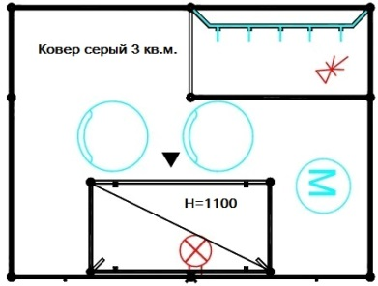

Equipment for the stand, area from 6 to 8 sq.m.

 | 6 m² | • floor carpeting (grey color)  • wall panels (color-white)  • fascia panel  • inscription on the fascia panel (no more than 20 characters, color blue)  • 2 spot sconces on the busbar  • 1 socket 220V (1 kW) (in case of payment  registration fee)  • 1 information Desk 500 x 1000 x 1100 mm  • 1 table 700 x 700 mm  • 2 chairs  • 1 wall hanger  • 1 dustbin

Equipment for the stand, area from 9 to 11 sq.m.

 | 9 m² | • floor carpeting (grey color)  • wall panels (color-white)  • fascia panel  • inscription on the fascia panel (no more than 20 characters, color blue)  • 2 spot sconces on the busbar  • 1 220V socket (1kW)  • 1 information Desk 500 x 1000 x 1100 mm  • 1 table 700 x 700 mm  • 3 chairs  • 1 wall hanger  • 1 dustbin

Back to table of contents

Equipment for the stand, area from 12 to 17 sq.m.

 | 12 m² | floor carpeting (grey color)  • wall panels (color-white)  • 1 sliding door  • fascia panel  • inscription on the fascia panel  (no more than 20 characters, color blue)  • 3 spot sconces on the busbar  • 1 220V socket (1kW)  • 1 information Desk 500 x 1000 x 1100mm  • 1 table 700 x 700mm  • 4 chairs  • 1 rack (4 shelves) 800 x 300 x 2000 mm  • 1 z-shaped card holder  • 1 wall hanger  • 1 dustbin

Equipment for the stand, area from 18 to 29 sq.m.

 | 25 м² | floor carpeting (grey color)  • wall panels (color-white)  • 1 sliding door  • fascia panel  • inscription on the fascia panel  (no more than 20 characters, color blue)  • 4 spot sconces on the busbar  • 1 220V socket (1kW)  • 1 information Desk 500 x 1000 x 1100 mm  • 1 table 700 x 1400 mm  • 4 chairs  • 1 rack (4 shelves) 800 x 300 x 2000 mm  • 1 z-shaped card holder  • 1 wall hanger  • 1 dustbin

Back to table of contents

Equipment for the stand, area from 30 to 42 sq.m.

 | 30 m² | • floor carpeting (grey color)  • wall panels (color-white)  • 1 sliding door  • fascia panel  • inscription on the fascia panel  (no more than 20 characters, color blue)  • 6 spot sconces on the busbar  • 1 220V socket (1kW)  • 2 information Desk 500 x 1000 x 1100 mm  • 1 table 700 x 1400 mm  • 1 table 700 x 700 mm  • 6 chairs  • 1 Cabinet 500 x 1000 x 700 mm (without lock)  • 1 rack (4 shelves) 800 x 300 x 2000 mm  • 1 z-shaped card holder  • 1 wall hanger  • 1 dustbin

Equipment for the stand, area from 43 to 54 sq.m.

 | 48 m² | • floor carpeting (grey color)  • wall panels (color-white)  • 2 sliding doors  • fascia panel  • inscription on the fascia panel  (no more than 20 characters, color blue)  • 8 spot sconces on the busbar  • 1 fluorescent lamp  • 1 220V socket (1kW)  • 4 information Desk 500 x 1000 x 1100 mm  • 1 table 700 x 1400 mm  • 1 table 700 x 700mm  • 8 chairs  • 1 Cabinet 500 x 1000 x 700 mm (without lock)  • 2 racks (4 shelves) 800 x 300 x 2000 mm  • 2 z-shaped holders  • 1 wall hanger  • 1 dustbin
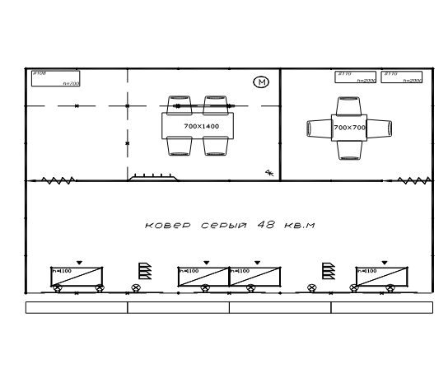

Back to table of contents

Annex No. 8. Stand equipment «PREMIUM»

Sample of standard stand
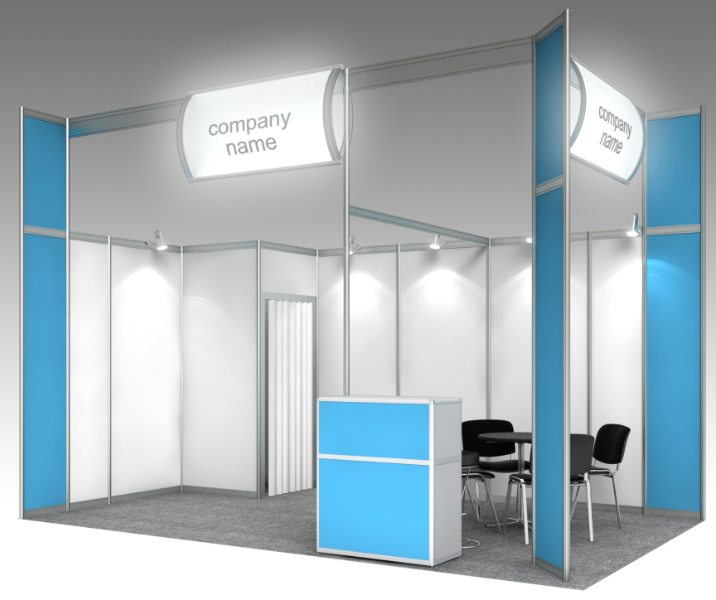

Standard stand equipment |  | 6-11 | 12 - 17 | 18 - 24 | 25-32
Carpet (color to choose: gray, blue, red, green)
The height of the stand structures is 3.5 m. the height of the stand walls is 2.5 m (with partial pasting with orakal 641 film)
Utility room with door | Sq.m. | - | 1 | 1 | 1
Fascia panel with internal illumination (on each open side) | Pc. | 1 | 1 | 2 | 2
Lighting of the total area of the stand. At the rate of 1 spot per 3 sq. m. area. | Pc. | 3 | 5 | 6-8 | 8-10
Triple Socket 1 kWt | Pc. | 1 | 1 | 1 | 2
Information Desk height 1,1 m. | Pc. | 1 | 1 | 1 | 1
Round table d-0.7м, 0,7х0,7, 1,2х0,7м (optional) | Pc. | 1 | 1 | 2 | 2
Meeting chair | Pc. | 3 | 4 | 6 | 6
Trash can | Pc. | 1 | 1 | 1 | 1
Wall hanger | Pc. | 1 | 1 | 1 | 1

Additional equipment is available on request.

Back to table of contents

Annex No. 9. Carpet colors.

Grey | Green
Dark Grey | Dark Green
Blue | Red
Deep Blue | Maroon
Dark Blue | Black

Back to table of contents

Annex No. 10. The color scale of the film ORACAL 641 series

Number | Color name | Color
000 | transparent
010 | white
020 | golden-yellow
019 | signal yellow
021 | yellow
022 | light yellow
025 | brimstone yellow
026 | purple-red
312 | burgundy
030 | dark red
031 | red
032 | light red
047 | orange red
034 | orange
036 | light orange
035 | pastel orange
404 | purple
040 | violet
043 | lavender
042 | lilac
041 | pink
045 | soft pink
562 | deep blue sea
518 | steel blue
050 | dark blue
065 | cobalt blue
049 | king blue
086 | brilliant blue
067 | blue
057 | traffic blue
051 | gentian blue
098 | gentian
052 | azure blue
084 | sky blue
053 | light blue
056 | ice blue
066 | turquoise blue
054 | turquoise
055 | mint
060 | dark green
613 | forest green
061 | green
068 | grass green
062 | light green
064 | yellow green
063 | lime-tree green
070 | black
073 | dark grey
071 | grey
076 | telegray
074 | middle grey
072 | light grey
080 | brown
083 | nut brown
081 | light brown
082 | beige
023 | cream
090 | silver grey (metallic)
091 | gold (metallic)
092 | copper (metallic)

Back to table of contents

Annex No. 11. Value of lost or damaged property

1. Value of lost or damaged property from the modular system «advantech»

№ | NAME | COST  in euro (excluding VAT)
1 | ADVANTEC 1000x3000 wall panel | 670
2 | ADVANTEC 500x3000 wall panel | 610
3 | ADVANTEC 287x3000 wall panel | 550
4 | ADVANTEC 623x3000 wall panel | 610
5 | ADVANTEC 667x3000 wall panel | 610
6 | ADVANTEC 700x3000 wall panel | 610
7 | ADVANTEC 1000x1000 wall panel | 430
8 | ADVANTEC 500x1000 wall panel | 310
9 | Swing door with lock ADVANTEC 1000x3000 (door block, door 2165) | 1 205
10 | ADVANTECH glass door, grey, 1000x3000 | 1 825
11 | ADVANTEC wall panel with glass 1000x3000 (glass 810x2090) | 970
12 | ADVANTEC wall panel with glass (glass 810x2090) and blinds 1000x3000 | 1205
14 | ADVANTEC light beam with busbar, p. M. | 240
15 | Wall shelf 1000x300 ADVANTECH | 310
16 | Information rack 400x1000 (chipboard) ADVANTEC | 610
17 | Wall hanger L=1000 ADVANTEC | 310

2. Value of lost or damaged audio-video equipment

№ | NAME | COST  in euro (excluding VAT)
1 | Plasma panel 42” | 555 euro /PC
2 | Plasma panel 50” | 1240 euro /PC
3 | Plasma panel 60” | 1670 euro /PC
4 | Plasma panel 75” | 3750 euro /PC
5 | Plasma panel 84” | 6670 euro /PC
6 | Led screen with 3.91 mm pixel pitch Unilumin Muslims 2.6 per 1 sqm | 2225 euro/sq.m.
7 | Led screen with 2.6 mm pixel pitch Unilumin UslimS 2.6 per 1 sqm | 3060 euro/sq.m.
8 | Laptop | 975 euro /PC
9 | Audio mixer | 1180 euro /PC
10 | Radio microphone | 1335 euro /PC
11 | Wired microphone | 210 euro /PC
12 | Floor stand for plasma panel 42-84” | 1210 euro /PC
13 | Wall mount for plasma panel 42-84” | 280 euro /PC
14 | Sound amplification kit 1.000 W – 5.000 W | from 1340 to 6950 euro /PC
15 | Conference equipment control unit | 695 euro /PC
16 | Conference equipment microphone console | 210 euro /PC
17 | Mobile sound amplification kit 300W | 560 euro /PC
18 | Mobile sound amplification kit 600W | 1115 euro /PC

Back to table of contents

Annex No. 12. List of Internet users and consent to the processing of personal data.

List of internet users during the Exhibition ________ Moscow
at the booth _____

№ | FIRST NAME | LAST NAME | PLACE OF RESIDENCE (FULL  ADDRESS) | PASSPORT NO. | DATE OF ISSUE | ISSUING  AUTHORITY

Head of company / organization:

___________________________________________ _______________________ «___» _______________ 20____
Name S.P. signature

Back to table of contents

